CHAPTER 6 - Selected Answers “Evens” p.1
Section 6.1 (p.326)
2. ‘Equivalent’ algebraic statements means the same ‘truth set’ which in this case is x > 6.
4. open 6. open 8. solid (or closed) 10. right 12. left 14. right 16. All real numbers less than or equal to -3 18. All real numbers greater than 0 20. not a solution 22. solution
24. A 26. B 28. E 30. add 2 32. add 4 34. subtract 17 (or add -17) 36. C 38. F 40. E
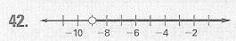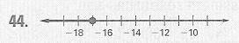
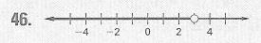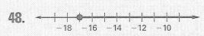
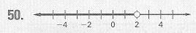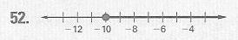
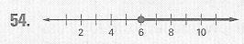 56. (a) 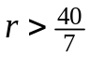 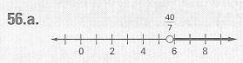 (b) no
58. 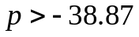 60. 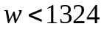 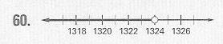
62. Add 10 to each side to get: 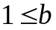 64. F 66. -4 68. -27 70. 15 72. 10 74. d = .12t
76. 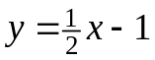 78. y = 4 80. y = x – 7 82. y = 2x – 7 84. 86.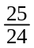 88. 90. 92. 94.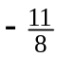
Section 6.2 (p.333)
2. No; -x < 2 is the same as 2 > -x. 4. multiply by 2 (do not reverse the sign) 6. divide by 8 (do not reverse) 8. multiply by -1 (reverse the sign) 10. equivalent 12. not; z < -15
14. equivalent 16. divide by 9 (do not reverse) 18. divide by 2 (do not reverse)
20. multiply by -3 (reverse the sign) 22. multiply by -6 (reverse) 24. not the solution
26. solution 28. not equivalent; 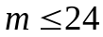 30. not equivalent; 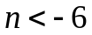 32. not; 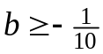
34. 0(-2)=0; 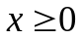 36. k > -20 38. a < 100 40. 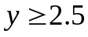 42.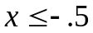 44.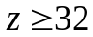 46. 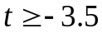
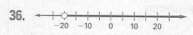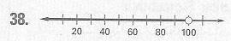
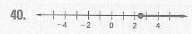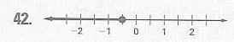
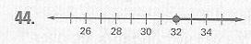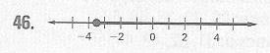
48. 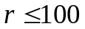; -50.1155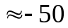 50. sometimes 52. sometimes 54. 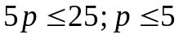
56. 16 or more lessons 58. x must be greater than zero but less than or equal to 2 60. F
62. -7 64. 4 66. -18 68. -2 70. 5 72. -46 74. 5 76. 13 78. m = dv 80. c = P – a – b
82. 1,2,7,14,49,98 84. 1,2,3,6,19,38,57,114 86. 1,17,289
88. 1,2,4,7,8,14,19,28,38,56,76,133,152,266,532,1064
90. 1,2,4,5,8,10,20,40,137,274,548,685,1096,1370,2740,5480
Selected Answers “Evens” p.2
Section 6.3 (p.339)
2. Subtract 2 from each side and divide each side by -3 to isolate the variable, y.
4. not multi-step, multiply by 6. multi-step, add 3 & divide by 4 8. multi-step, subtract 10 (or add -10) from each side & multiply by -1 (don’t forget to reverse the inequality!)
10. multi-step, subtract 3m & divide by 4 12. 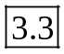, 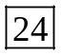, 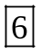 14. add 4, divide by 7
16. subtract 5, multiply by 18. subtract 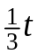, subtract 5 20. x > -18 22. 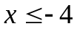 24. -3 > x
26. 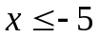 28. -9 < x 30. B 32. 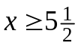 34. x < -5 36. 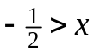 38. 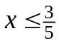 40. 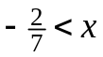
42. Add 4 to each side in the 2nd line; 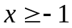 44. 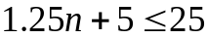 46. ‘price per topping’ times ‘number of toppings’ plus ‘cost of chees’ ‘amount of money you have’
48. 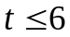; you may purchase up to 6 additional toppings 50. 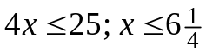
52. 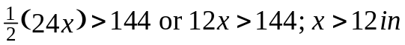 54. F 56. -10 58. 12 60. c > 2s 62. 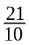 64. 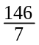
Section 6.4 (p.345)
2. You are ‘putting together’ the two parts 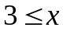 and x < 9 into one inequality 4. B
6. (2x + 3) is greater than -1 and less than or equal to 13. 8. 2 < x < 5 10. 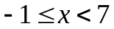
12. x is greater than 0 and less than 18. 14. 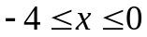 16. 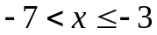
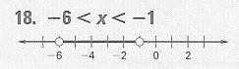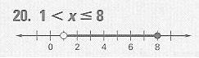
22. 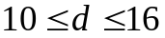 24. 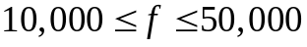 26. 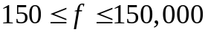
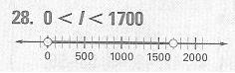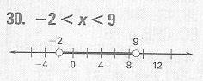
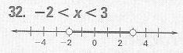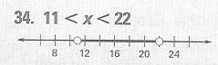
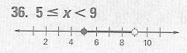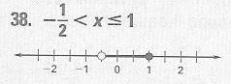
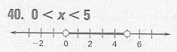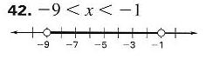
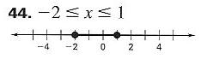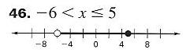
48. D 50. 7 52. 10 54. 16.5 56. 1 58. 6 60. -10 62. 6 64. 9 66. -7 68. P = 2.6t + 249
70. 25% 72. 40% 74. 74% 76. 15%

Selected Answers “Evens” p.3
Section 6.5 (p.351)
2. C 4. D 6. all real numbers less than or equal to -25 or greater than 7 8. all real numbers less than -9 or greater than 3 10. x < 0 or 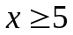 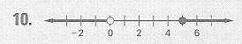
12. all real numbers less than 0 or greater than 16 14. 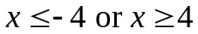 16. 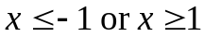 18. x < -6 or x > 2 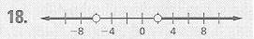
20. x < 3 or x > 10 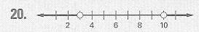
22. 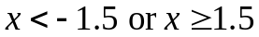 24. 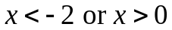 26. 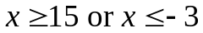 28. 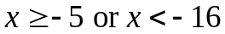
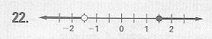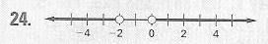
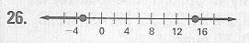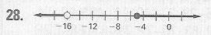
30. 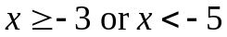, not a solution 32. 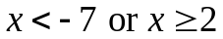, solution
34. x < -3 or x > 11 36. 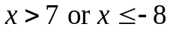 38. 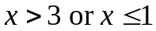 40. 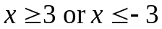
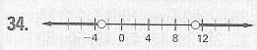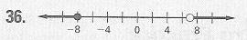
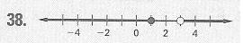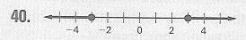
42. t < .5 or t > 1.5 44. 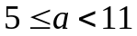 46. all real numbers 48. H
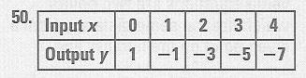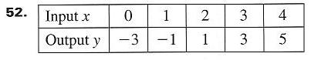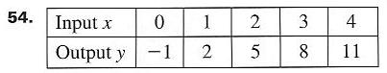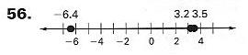
58. 5.17 60. 5.81 62. 2.36 64. x > -12 66. 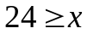 68. 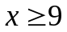 70. x > -9 72. 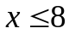
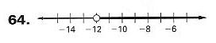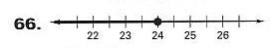
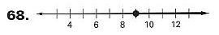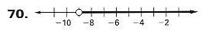
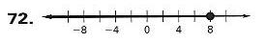
74. 75 76. 3000 78. 3600 80. 3500
Selected Answers “Evens” p.4
Section 6.6 (p.358)
2. A, C; 20, -6 4. none 6. one 8. 2x – 3 = -8 or 2x – 3 = 8 10. 3x + 2 = -6 or 3x + 2 = 6
12. no solution 14. 10, -10 16. 2, -4 18. 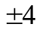 20. 1, -17 22. no solution 24. 60, -70
26. -12, -18 28. always 30. sometimes 32. 1, 34. 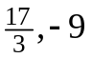 36. 7, -6 38. 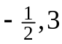 40. 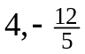 42. C 44. 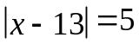 46. 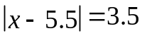 or 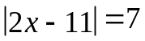 48. 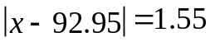 50. D
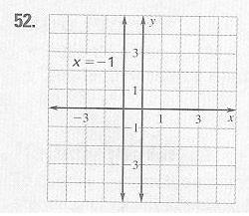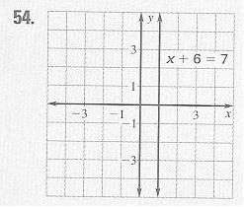
56. y = 3x – 21 58. y = 3x + 4 60. y = 2x + 7 62. 47,509.1 64. 47,509,126 66. 47,509

Section 6.7 (p.364)
2. A 4. B, D; or 6. not 8. 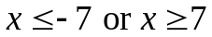 10. 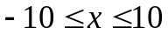(and) 12. 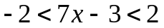(and) 14. 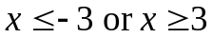 16. 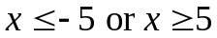 18. 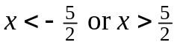 20. 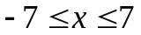
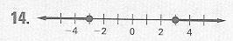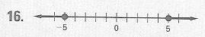
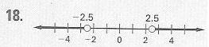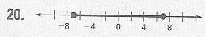
22. 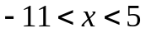 24. 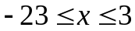
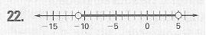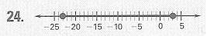
26. always 28. sometimes
30. 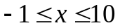 32. 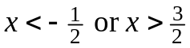 34. 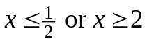 36. 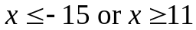
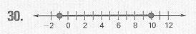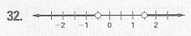
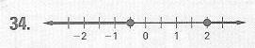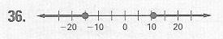
38. 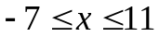 40. 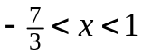
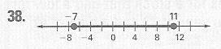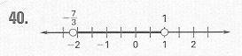
Selected Answers “Evens” p.5

42. t < 2 or t > 4 44. blue 46. orange-red 48. D 50. all real numbers 52. all real numbers except -1 (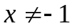) 54. 1802 pesos 56. (sample answers) (0,4),(1,4),(-2,4) 58. function
60. not a function 62. 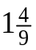 64. 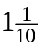 66. 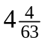

Section 6.8 (p.370)
2. not a solution 4. D 6. below 8. not a solution 10. solution 12. solution
14. (0,0) is a solution 16. (1,2) is a solution 18. neither ordered-pair is a solution
20. B 22. A 24. dashed or dotted line 26. y = -x – 15, dotted 28. y = -4x + 9, dotted
30. y = -2x + 3, dotted 32. y = 2x – 1 34. (0,0) is a solution
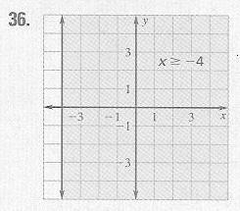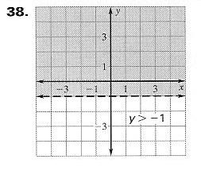
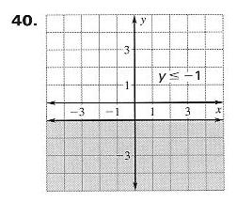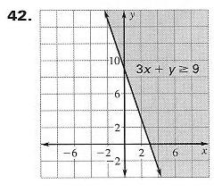
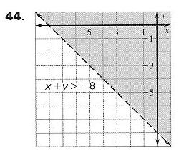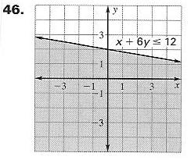
Selected Answers “Evens” p.6
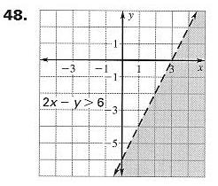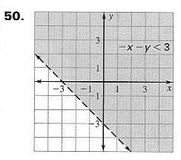
52. (sample answer) (4,1), (1,3), (2,2) 54. (sample answer) (1000,1200) gold & silver coins; (600,1500), 600 gold coins and 1500 silver coins 56. J 58. 19 60. 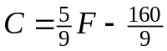
62. m = -5, b = 2 64. m = 1, b = 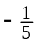 66. m = 0, b = -2 68. 36% 70. 34%

Chapter 6 Summary and Review (p.375)
2. a > 22 4. 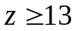 6. k < 5 8. -9 < r 10. 15 < x 12. 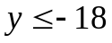
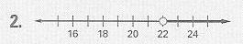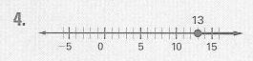
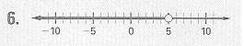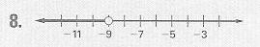
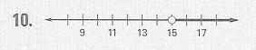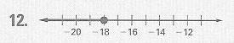
14. x > 5 16. 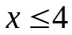 18. x < -4 20. x > 3
22. 8 < x < 12 24. 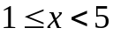 26. 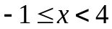 28. 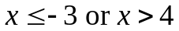
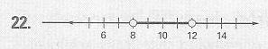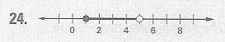
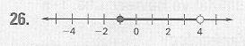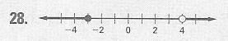
30. 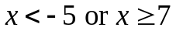 32. x < 2 or x > 10
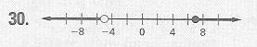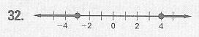
34. 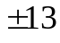 36. 7, -5 38. 2, 1 40. 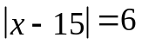
Selected Answers “Evens” p.7
42. 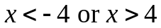 44. 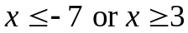 46. 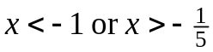 48. 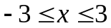
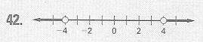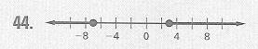
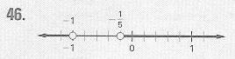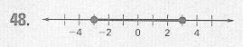

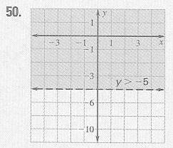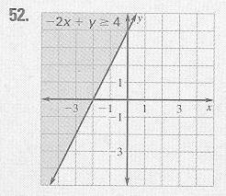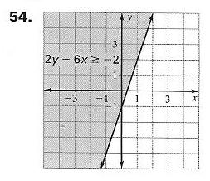

Chapter 6 Test (p.379)
1. x < 13 2. x < -11 3. 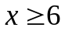 4. 5. x > -7 6. x > -6 7. x < -9 8. 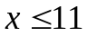 9. x > 9
10. 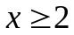 11. 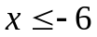 12. x < 5 13. 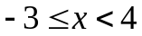 14. 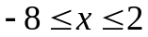 15. 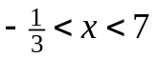16. 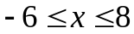
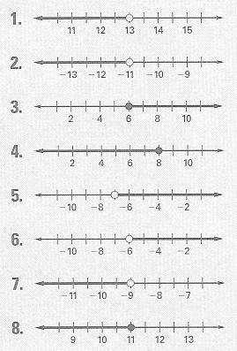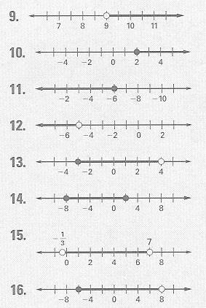
Selected Answers “Evens” p.8
17. x 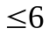 or x > 10 18. x < -6 or x > 6 19. x < -2 or x > 2 20. x < 2 or x > 5
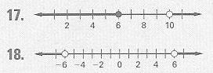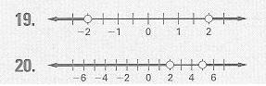
21. 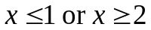
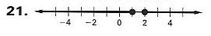
22. 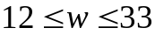 23. 4, -18 24. 4, 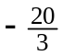 25. 21, -5 26. 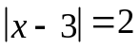 27.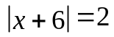 28. 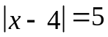
29. x < -7 or x > 7 30. 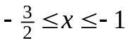 31. -1 < x < 7
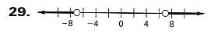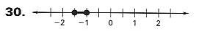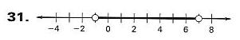
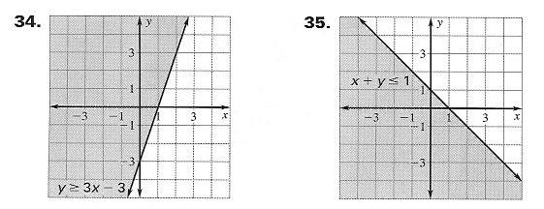
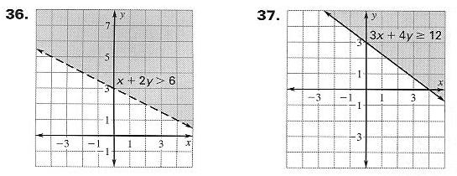
38. 2x + y < 100, x is the number of sandwiches and y is the number of drinks
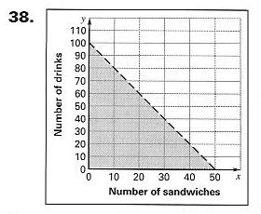
39. (sample answer) (20,50) meaning 20 sandwiches and 50 drinks, (30,30)
Selected Answers “Evens” p.9

Chapter 6 Standardized Test (p.380)
1. D 2. D 3. B 4. D 5. A 6. A 7. D 8. C 9. B

Maintaining Skills (p.265)
2. 86 4. 78 6. 56 8. 64 10. -14 12. -18 14. -2 16. 14

---------------------- Cumulative Practice Chapters 1-6 (p.382) -------------------------
2. 19 4. -12 6. 3 8. -3 10. -8 12. -20 14. velocity = -800 ft/min, speed = 800 ft/min
16. 4a – 16 18. 10 + 2n 20. 3x 22. 2x + 27 24. -5 26. -6 28. 3 30. 12 32. 5 34. 2
36. v = m/d 38. $.50/can 40. $12/h
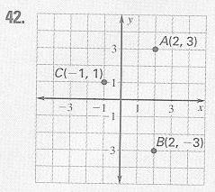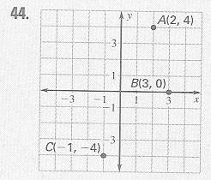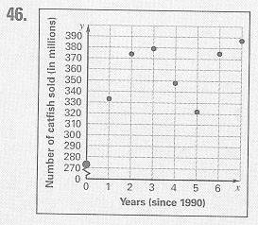

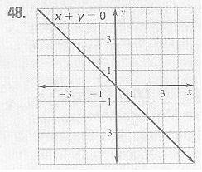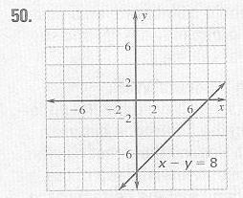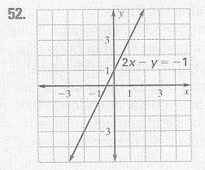

54. y = x – 3 56. y = 0 58. y = 2x + 3 60. y = 3 62. y = -5x – 9 64. y – 0 = 1(x – 2)
or y – (-2) = 1(x – 0) 66. y – 10 = -4(x – 1) or y – 2 = -4(x + 2) 68. 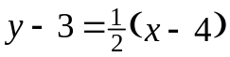 or
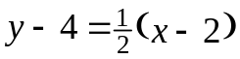 70. 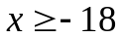 72. 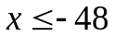 74. x < 6 76. 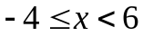 78. x < 2 or x > 5
80. x < -2 or x > 18
-----------------------------------------------------------------------------------------------------------

