2006 AP Calculus AB – Part A (with calculator) - Solutions
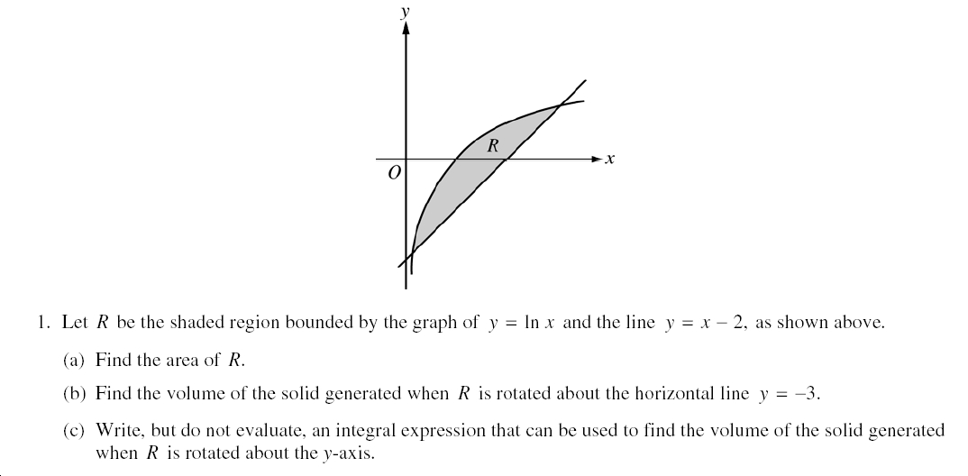

(a) Using ‘Vertical Strips’… 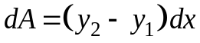 where 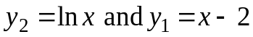
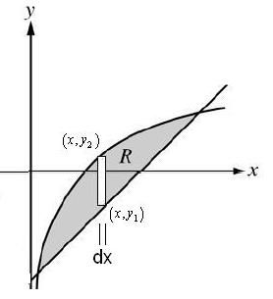
Then 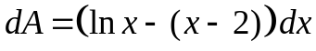
and 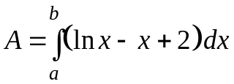 1pt – integrand
where 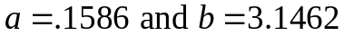 1pt – for 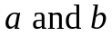

and we obtain: 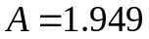 1pt – answer

(b) and (c) using ‘Vertical Strips’… (b) results in the Washer Method (c) the Shell Method
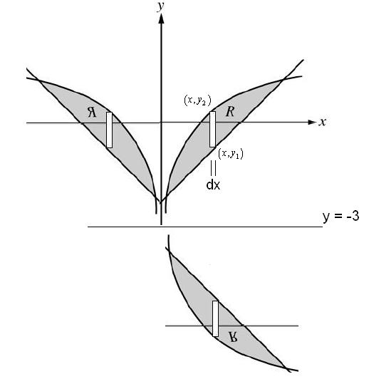
(b) 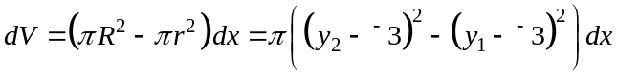
hence: 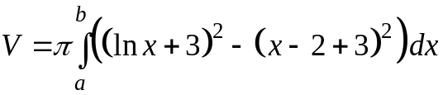
= 34.198 or 34.199
(Here 2 pts for the integrand and 1 pt only for limits of integration, constant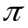, and answer)

(c) 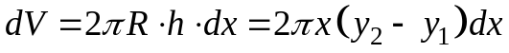
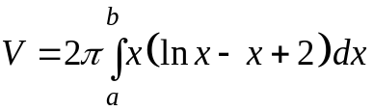
where (as above)
(2 pts for the integrand and 1pt for limits & constant 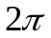)
2006 AP Calculus AB – Part A (with calculator) – Solutions
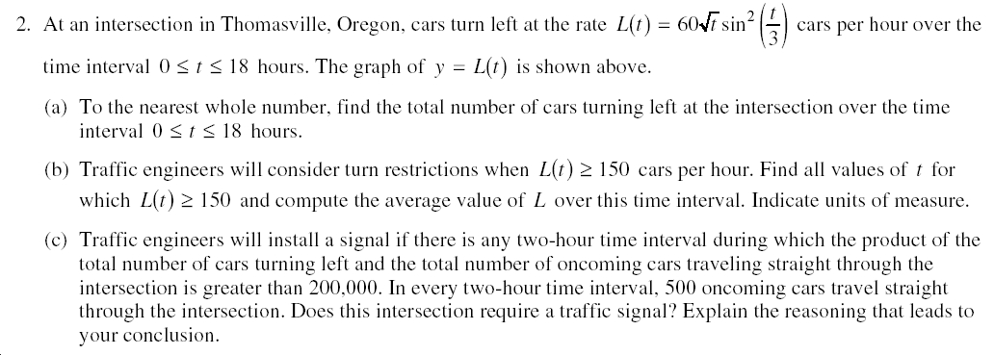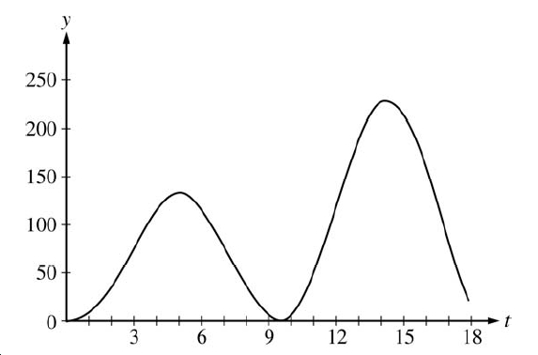
(a) 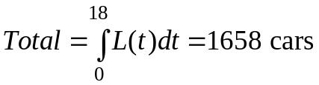 (1 pt for the setup and 1 point for the answer)
*Notes: (1)You can use and expression such as L(t) if either you or the exam defines it.
(2) The question asks for the “nearest” whole number of cars! Get the answer pt!
(b) On the graph of y₁ = L(t), graph the horizontal line: y₂ = 150 and find the intersection.
Let , so…
(i) or 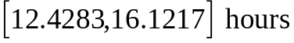 (1 pt for interval)
(ii) AV(f(x)) = 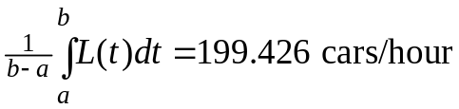 (1 pt for avg value, 1pt – answer)
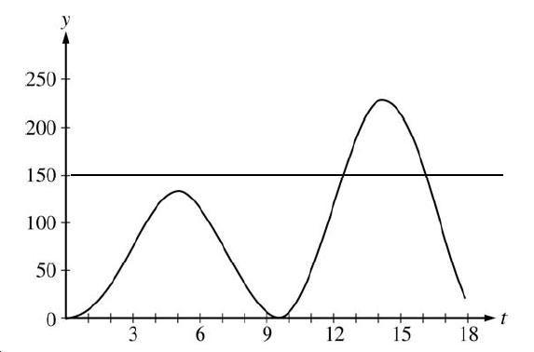
*Notes: (1) To get the setup point, the limits of integration, , must be defined.
(2) No credit (in this instance) for the answer if units are omitted.
(c) Whew! 2 hr interval, P(product) = multiplication (Don’t ask why we’re mutliplying!), Total Lefts = integral over some 2 hr interval, Total Straights = 500 for every 2 hr interval (Don’t ask why it’s a constant!), and why the product P > 200,000 to put in a light? (Don’t ask!)…
Here we go… we need P = (Total Lefts) (Total Straights) > 200,000 to get the light.
(yeah, yeah… in some 2 hr period) anyway, since Straights are always 500 per 2 hours,
What we need is for Total Lefts > 200,000/500 or Total Lefts > 400 for some 2 hr time.
Total Lefts is the area under the curve and to maximize this, we find that the time of
maximum left turns is around 14.5 hours, so integrate 1 hr left(less) to 1 hr right(more)
Let’s try: 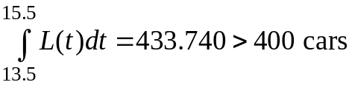 …so yes, put in the $%& traffic light!
*Note – Another method (that works in this instance) would be to draw the line, y = 200 cars/hr, and show that there is a 2hr time interval when L(t) > 200 (always isn’t necessary).
2006 AP Calculus AB – Part A (with calculator) – Solutions
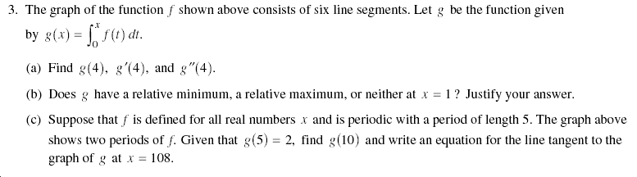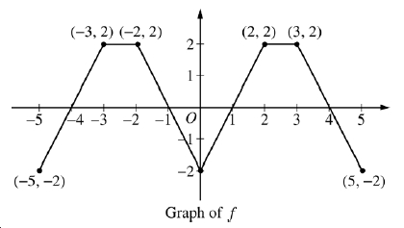
(a) g(x) is called an ‘integral function’ but I like to think of it as an accumulation function!
Anyway… g(4) is the integral from x = 0 to x = 4, so find the ‘area’ of 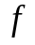
(i) g(4) = 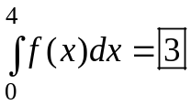 since the ‘negative area’ or triangle cancels out a ‘positive.’
(ii) To say g(x) is the anti-derivative of ‘f’ or integral of ‘f’ is to say that “g(x) is a
function whose derivative is ‘f’.” or 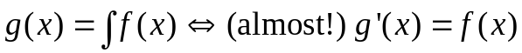
A quick example before moving on… 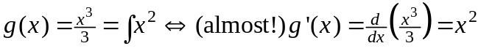
Moving on… 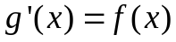 hence 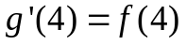 which is the y-value of 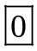 (see graph).
(iii) If , then 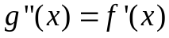, so check the slope of the graph at x = 4 or 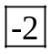
(3 pts, one for each boxed answer, no work required here)
(b) max/min problem? for g at x = 1 …no problem! just draw the 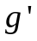 (which 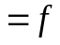) number line from thegraph above just around x = 1.
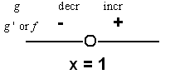
Hence, we have a local minimum at x = 1,
because changes from negative to positive!
*Note: Since around 2004, the number line isn’t quite enough to get the explanation point!
The correct conclusion (the ‘hence’ part) gets 1 pt
The explanation (the ‘because’ part) gets 1 pt
(c) Okay, the graph of ‘f’ above does repeat every 5 units (period of f is 5)…
g(5) is still ‘area’ or integral and if I cancel out the triangles, yes the area is 2…
g(10) is the ‘area’ from 0 to 10, but since the graph repeats, the answer is just 2(2) = 4

Now what’s this about the tangent line equation? Point-slope form! (I can feel it coming!)… y – y₀ = m(x – x₀) where the point is at x = 4. Be careful! We’re talking about a tangent to the graph of g (which we can’t see!) , forget the graph of f above!
The point on g is (108, g(108)) and the slope m = 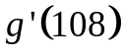 is given by 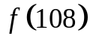…
Confusing! Well, let’s start with the slope, is the y-value on the graph which is periodic with period 5 units. So f(108) = f(3) = 2 = m
Next g(108) = g(105) + the area of the left-over portion (2 also!) = 21(2) + g(3) = 42+2
or 44, so we have the point (108,44) and the line: y – 44 = 2(x – 108)
2006 AP Calculus AB – Part B (no calculator) – Solutions
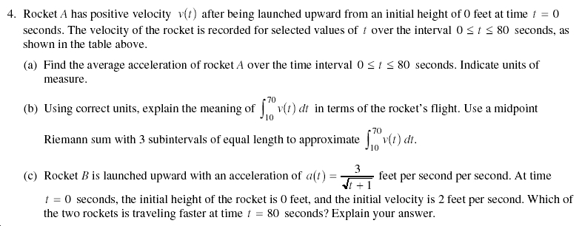
(a) 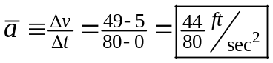 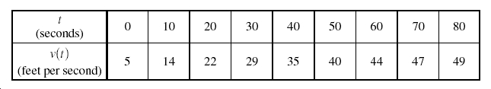
[1 pt - answer]
(b) (i) The definite integral from 10 to 70 seconds is the displacement (or distance traveled
here) in feet (in the vertical direction).
(ii) Ah… Smidpoint! with 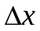= 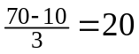, the partition being 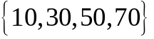…
so the midpoint x-values we’ll use to get the y-values are actually 20, 40, and 60
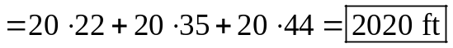
[3 pts – 1 for (i), 1 for using midpoints, x = 20,40,60 and 1 for the answer (see units below)]
(c) Rocket A (from the chart) has a v(80) = 49 ft/sec
Find the velocity function for Rocket B. Integrate its acceleration, 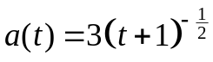
, to find C, we plug back in,
using v(0) = 2 ft/sec (given in the problem): 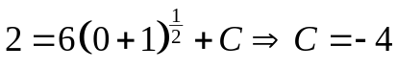
so 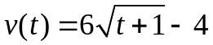 and > 49 ft/sec
Hence, Rocket B is traveling faster than A at 80 seconds.
[4 pts – 1 for getting 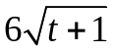, 1 for remembering the integration constant, C, and 1 for using the initial condition that v = 2 ft/s when t = 0 sec to get C = -4, and 1 for comparing the velocities and drawing the correct conclusion.]

Hey, this only adds up to 8 points? Where’s the 9th point?
[1 point for correct units in parts (a) and (b). NO half-points here, all or nothing!]
2006 AP Calculus AB – Part B (no calculator) – Solutions
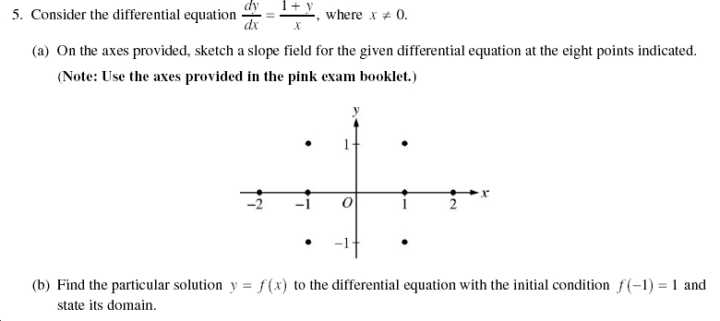
- [2 pts for the correct slope and relative steepness of each segment]
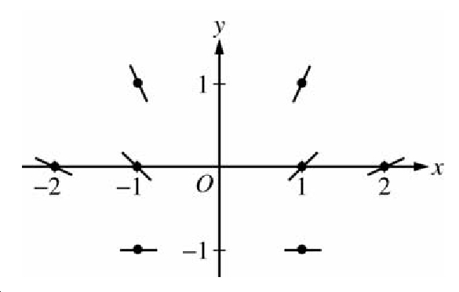
(b) [1 pt – separating the variables] 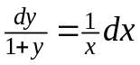
[2 pts – integration (antiderivatives)] 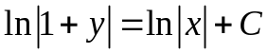 (since ln(-1) DNE)
[1 pt – constant of integration, C only]
Now ‘exponentiate’ both sides: 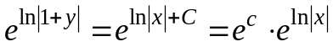
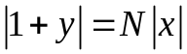or |1 + y| = C|x| [1 pt – using the initial condition to find C] y(-1)=1 (we’ll use |x| = 1 here)
*We’ll have to recall or use absolute values here:
1+1 = C|-1| 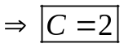
[1 pt – solving for y] 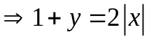 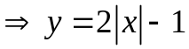

[1 pt – stating the Domain] Way at the top, we see 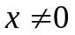 and we’re given x = -1
So our domain for a differentiable function is: x < 0
2006 AP Calculus AB – Part B (no calculator) – Solutions
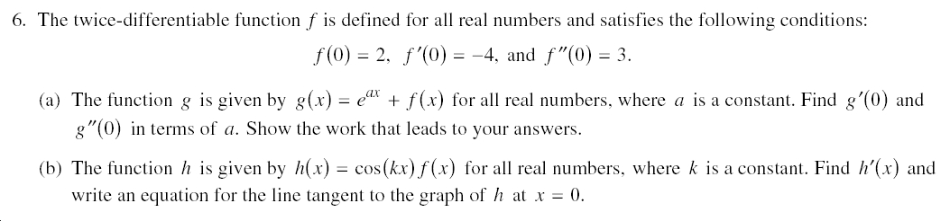
On these ‘theory’ problems, try to figure out what each part is all about. Is it an average value problem? (No, we already did that one.) Is it a Mean Value Theorem problem? (Nope.) Is it integration? (Don’t think so.) Wait, I see a tangent line problem! I see 1st and 2nd derivatives! I can do this! (Or at least get some partial credit?)

- (i) 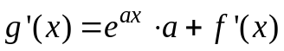, so [2 pts]
(ii) 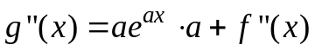, so 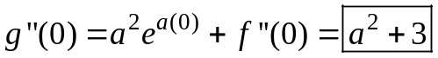 [2 pts]
*Note 1 for each boxed answer and 1 for each derivative (show your work!)

(b) Do you see the product function (rule) here? 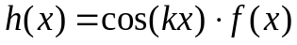
(i)
(ii) Point-slope form for a line (once again!): y – y_{o} = m(x – x_{o})
Point: (0, h(0)) = (0, cos(0)f(0)) = (0,2)
Slope: m =
Answer: 

