Vectors and Projectile Motion – Ch 3 Evens p. 1

Properties of Vectors
2. (a) What is the resultant displacement of a walk of 80m followed by a walk of 125m when both displacements are in the eastward direction? (b) What is the resultant displacement in a situation in which the 125m walk is to the west and the 80m walk is to the east?
4. Each of the displacement vectors, and(shown below) has a magnitude of 3m. Find graphically (a) +, (b) 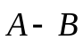, (c) 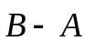, (d) 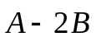.

Problem 4 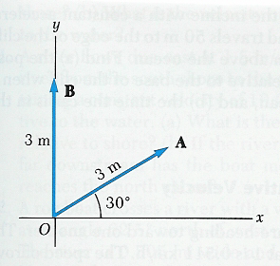 Problem 12 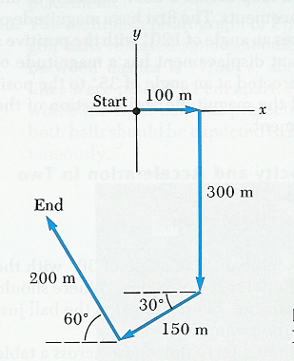

6. A dog searching for a bone walks 3.5m south, then 8.2m at an angle of 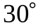north of east, and finally 15m west. Find the dog’s resultant displacement vector using graphic methods.
8*. A man lost in a maze makes three consecutive displacements such that at the end of the walks he is right back where he started. The first displacement is 8m westward, and the second is 13m northward. Find the magnitude and direction of the third displacement using the graphing method.

Components of a Vector
10. A submarine dives at an angle ofwith the horizontal and follows a straight-line path for a total distance of 50m. How far below the surface of the water is the submarine?
12*. A person going for a walk follows the path shown above. The total trip consists of four straight-line paths. At the end of the walk, what is the person’s resultant displacement measured from the starting point?
14*. An airplane flies from city A to city B in a direction due east for 800mi. In the next part of the trip the airplane flies from city B to city C in a direction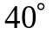north of east for 600mi. What is the resultant displacement of city C with respect to city A?
16*. A man pushing a mop across a floor causes it to undergo two displacements. The first has a magnitude of 150cm and makes a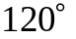angle with the positive x-axis. The resultant displacement has a magnitude of 140cm and has a direction angle of 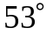. Find the magnitude and direction of the second displacement.
Vectors and Projectile Motion – Ch 3 Evens p. 2

Projectile Motion
18*. Tom the cat is chasing Jerry the mouse across a table 1.5m high. Jerry steps out of the way at the last second, and Tom slides off the edge of the table at a speed of 5m/s. Where will Tom strike the floor and what velocity components will he have just before landing?
20*. A brick is thrown outward from the top of a building at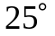above the horizontal and with an initial speed of 15m/s. If the brick is in flight for 3s, how tall is the building?
22. Two objects are initially the same height above the ground. Simultaneously, one is released from rest and the other is shot off horizontally with an initial speed of 2.5m/s. The two objects collide after falling 20m. How far apart were the objects initially?
24. A car is parked on a cliff overlooking the ocean on an incline that makes an angle of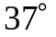below the horizontal. The negligent driver leaves the car in neutral, and the emergency brakes are defective. The car rolls from rest down the incline with a constant acceleration of 4m/s² and travels 50m to the edge of the cliff. The cliff is 30m above the ocean. Find (a) the position of the car relative to the base of the cliff when it lands in the ocean, and (b) the time the car is in the air.

Relative Velocity
26. A motorist traveling west on Interstate Route 80 at 80km/h is being chased by a police car traveling at 95km/h. (a) What is the velocity of the motorist relative to the velocity of the police car? (b) What is the velocity of the police car relative to the motorist?
28. A boat moves at 10m/s relative to the water regardless of which direction it travels through the water (still-water speed). If the water in a river is flowing at 1.5m/s, how long does it take the boat to make a round trip consisting of a 300m displacement downstream followed by a 300m displacement upstream?
30*. Two canoeists in identical canoes exert the same effort paddling and hence maintain the same speed relative to the water. One paddles directly upstream (and moves upstream), whereas the other paddles directly downstream. If the downstream direction is the positive direction, an observer on shore determines the velocities of the two canoes to be -1.2m/s and 2.9m/s respectively. (a) What is the speed of the water relative to the shore? (b) What is the velocity of each canoeist relative to the water?
32*. A rowboat crosses a river with a velocity of 3.3mi/h at an angle of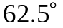north of west relative to the water. The river is .505mi wide and carries an eastward current of 1.25mi/h. How far downstream is the boat when it reaches the opposite shore?
34*. A car travels due east with a speed of 50km/h. Rain is falling vertically with respect to the Earth. The traces of the rain on the side windows of the car make an angle of 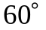 with the vertical. Find the velocity of the rain with respect to (a) the car and (b) the Earth.
Vectors and Projectile Motion – Ch 3 Evens p. 3

Additional Problems
36. A baseball is thrown by an outfielder at a speed of 20m/s at an angle of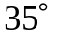above the horizontal. Find (a) the component of velocity along the ground at the instant the ball is released and (b) the upward component of velocity at this instant.
38*. A shopper in a department store can walk up a stationary (stalled) escalator in 30s. If the normally functioning escalator can carry the standing shopper to the next floor in 20s, how long would it take the shopper to walk up the moving escalator.
40. A multiflash photograph (see below) shows two golf balls released simultaneously. The time interval between flashes is 1/30 sec, and the white parallel lines were placed 15cm apart. (a) Find the speed at which the right ball was projected and (b) show that both balls should be expected to reach the floor simultaneously.

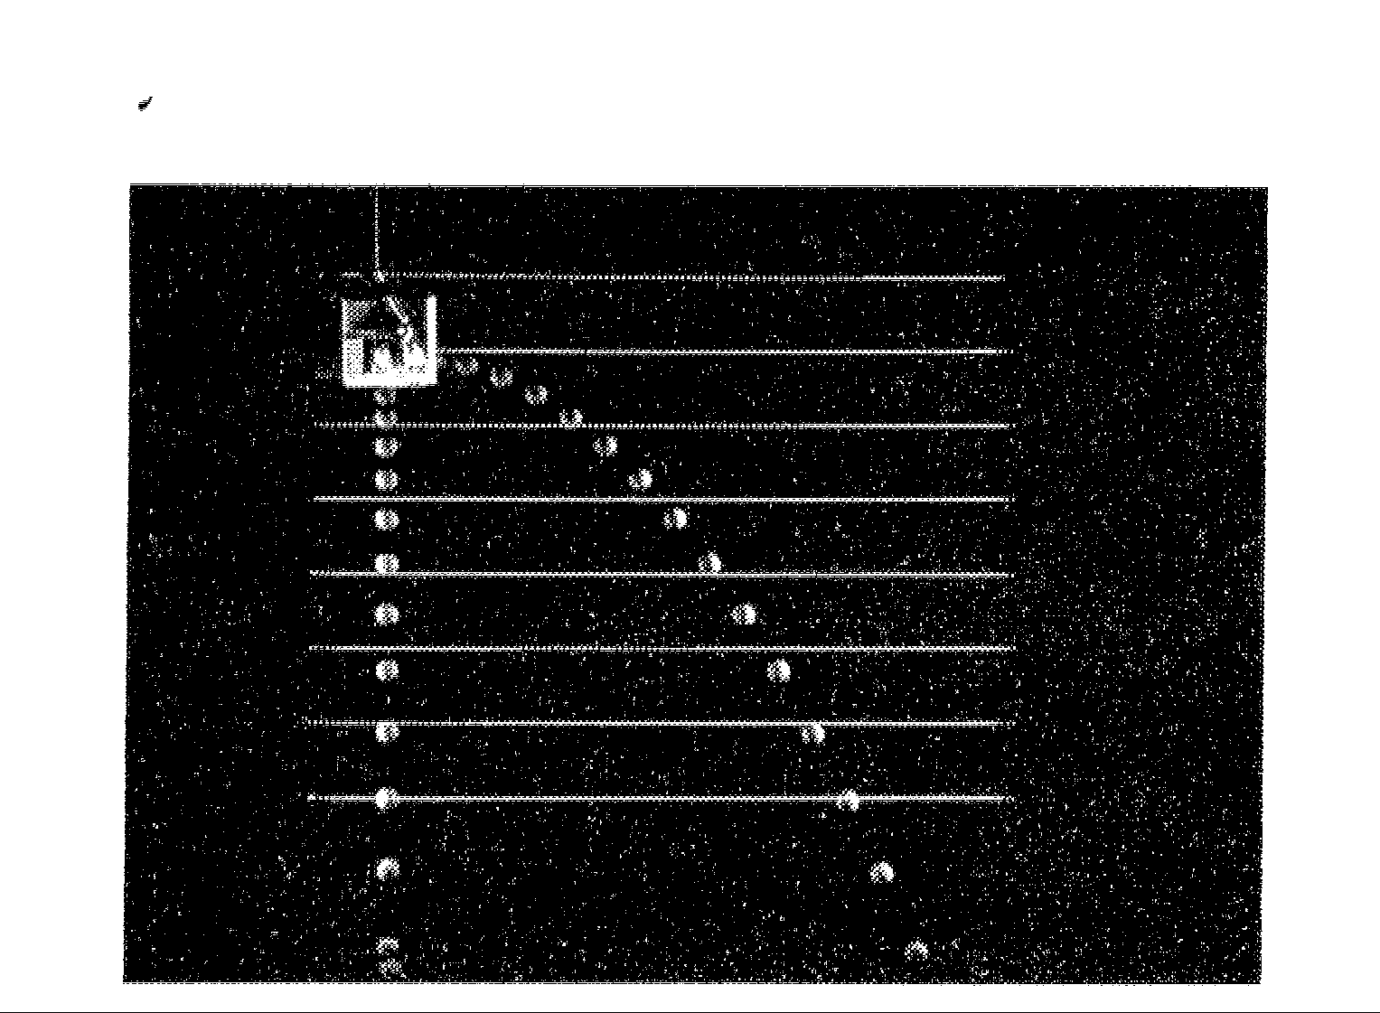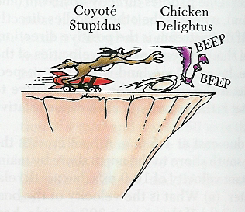
Problem 40
Problem 48

42*. A baseball is hit in such a way that the ball just clears a wall 3m tall, 130m from home plate (horizontal distance). The ball leaves the bat with a angle of inclination and is initially 1m above the ground. Find the ball’s initial velocity.
44*. A daredevil is shot out of a cannon at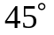to the horizontal with an initial speed of 25m/s. A net is located at a horizontal distance of 50m from the cannon. At what height above the cannon should the net be placed in order to catch the daredevil?
46**. A rocket is launched at an angle ofabove the horizontal with an initial speed of 100m/s. It moves along its initial line of motion with an acceleration of 30m/s² for 3s. At this time its engines fail and the rocket proceeds to move as a free body. Find (a) the maximum altitude reached by the rocket, (b) its total time of flight, and (c) its horizontal range.
48**. The determined coyote is once again out hunting for roadrunner soup. (See figure above.) The coyote wears a new pair of Acme power roller skates which provide a horizontal acceleration of 15m/s² as shown below. The coyote starts up from from rest 70m from the edge of the cliff just as the roadrunner zips by toward the cliff edge. (a) If the roadrunner moves with constant speed, determine the minimum speed necessary to just reach the cliff edge before the coyote does. (b) If the cliff is 100m above the base of the canyon, determine how far from the base of the cliff the coyote lands. (Assume that his Acme roller skates continue to ‘jet’ the coyote in the horizontal direction with the same acceleration magnitude as before.)
Vectors and Projectile Motion – Ch 3 Evens p. 4

50** In a popular lecture demonstration, a projectile is fired at a falling target. (See below.) The projectile leaves the gun at the same instant that the target is dropped from rest. Assuming the gun is initially aimed at the target, show that the projectile will always hit the target an any sufficient speed. Use v₀ for initial speed and for the angle of elevation.
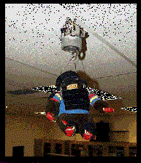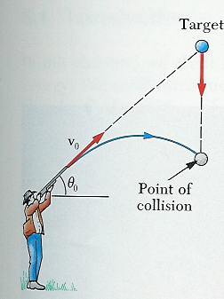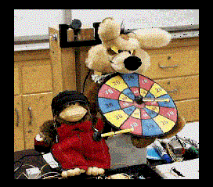

52. A vector has a magnitude of 100 units. Find its components (ordered-pair form) when it makes the following angles with the x-axis. (a), (b)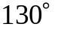, (c)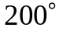, (d)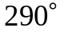.
54**. The figure below illustrates the difference in proportions of the male and female anatomy. The displacements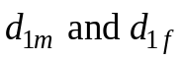 from the ground up to the navel have magnitudes of 104cm and 84cm, respectively. The displacements 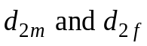 to the finger tips have magnitudes 50cm and 43cm respectively. (a) Find the vector sum of the two displacements for the male and then for the female.

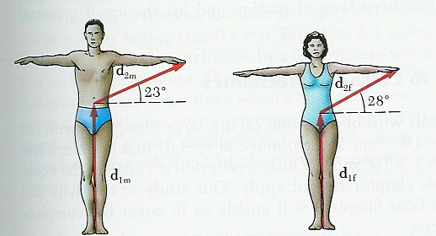 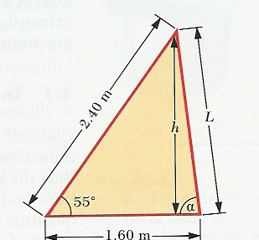 Problem 54 Problem 56
56*. Find the height h, the length of the side, L, and the angle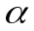 of the triangle shown above.

