Chapter 11 Sections 11.1–11.2 Even Answers Mostly
Section 11.1 Class Exercises
1. (-1, 3), R = 5 2. (2, -3), R = 5 3. (x – 1)² + (y + 7)² = 36 4. 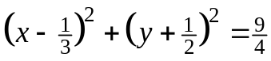
5. (x + 2)² + y² = 64 6. (x – 4)² + (y – 2)² = 17 7. (x + 2)² + (y + 3)² = 169
8. C(0,0) 9. C(3,-2) 10. 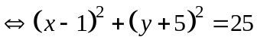
8. 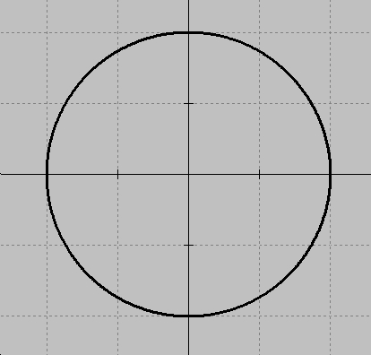 9. 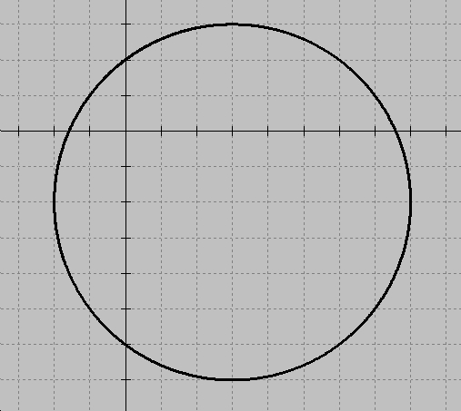 10. 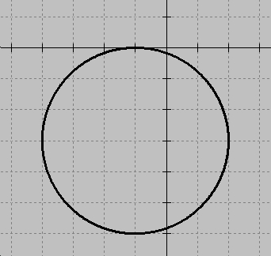
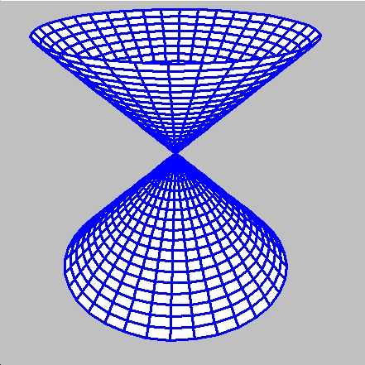
11. (2,-1), R = 6 12. (-1, -3), R = 9
13. Let be the vertex(cone) angle. Then the plane must intersect the
double rt circular cone at an angle less than 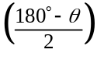. x² + y² – z² = 0
Section 11.1 Practice Exercises
2. (0,0), R = 10 4. (0, -3), R = 5 6. (-3, 4), R = 6 8. (-4, 5), R = 8 10. R = D/2, C=midpt
11. 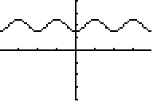 12. x² + y² = 9 14. (x – 5)² + (y – 6)² = 1 16. (x – 1)² + (y – 5)² = 45
18. x² + (y + 3)² = 25 20. (x – 3)² + (y – 1)² = 16 22. same area, no
24. The general equation of a circle has A = C. Also, it contains no xy-term (which rotates the other conic sections). 26. x² + (y + 2)² = 9 28. (x + 2)² + (y – 2)² = 50 30. One circle is inside: A_{big} – A_{small}
32, 34. circles 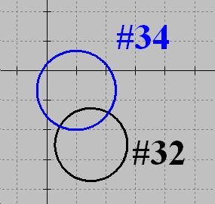 36. point 38. point 40. (-2,3), R = 5 42. (5,6), R = 11
44. 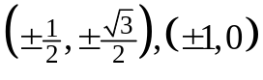 45. Intersect: y = .5x + 3 with the 45º line, y = x to find the center.
46. 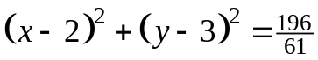 48. (x + 6)² + (y + 11)² = 260
50. Completing the square yields: 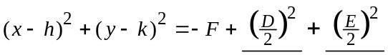= 0, when 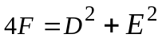
51. Tangents to a circle are  to radii drawn to the point of tangency. Hence the radii lie on: 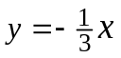.
Substitute into the equation of the circle to find the pts of tangency: 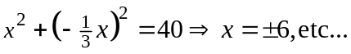 52. I’ll have to try this proof someday! Answer? The locus of pts is a circle with R = a, C(a/2, 0)
54. 320.5 cm 55. 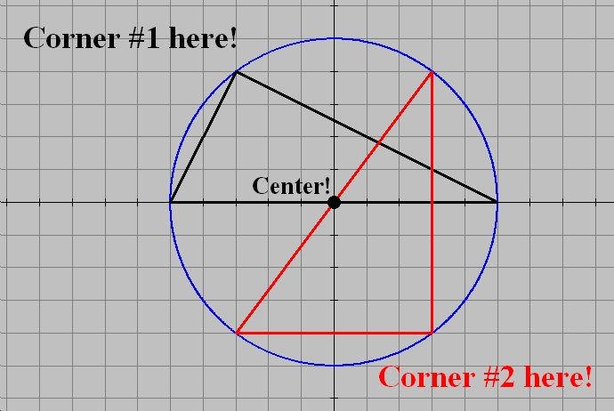
56. bisectors will intersect at the center. Just make sure the 3 pts are not collinear.
Review 11.1
1. Prove??? Well, if I can use: 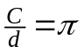, then it’s easy. Here’s a link to Archimedes’ Proof.
2. 6 N, 4 D, 2Q 3. 113. 1 4. 48.5 5. 374.1 6. 172.5 7. no common solution
8. yes, lines coincide 9. 18 10. ¾ 11. 19.43 ft 12. 28º
Section 11.2 Class Exercises
1. 2a = 18, 2b = 8, 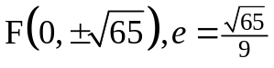 2. 2a = 8, 2b = 6, 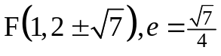
1. 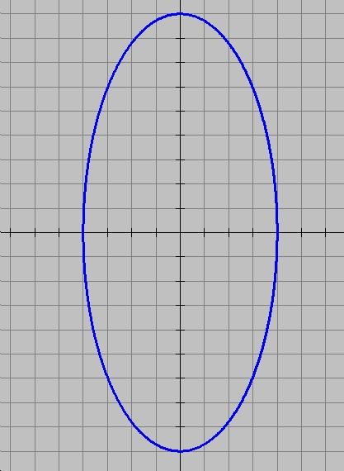 2. 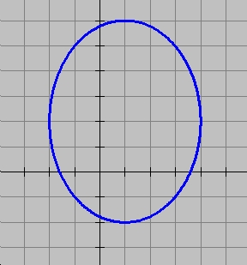 3. 2a = 6, 2b = 4, 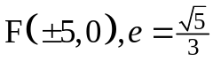 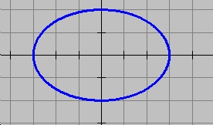
4. 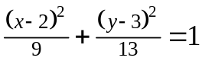 5. 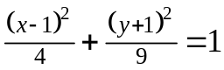 6. 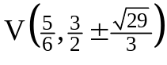 7. 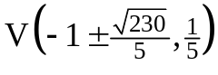
4. 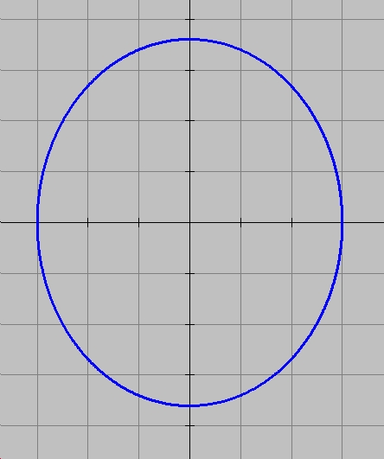 5. 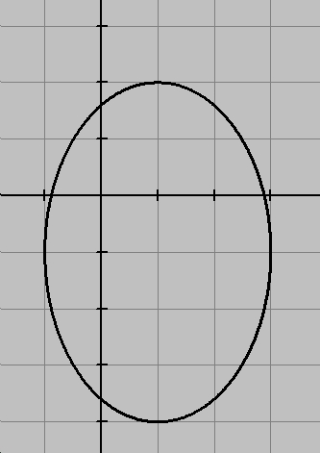 6. 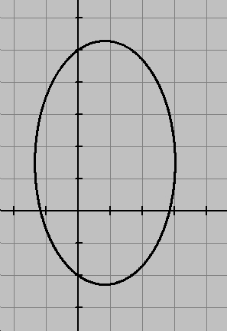 7. 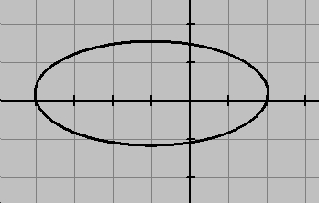
8. circle, C(0,0), R = a 9. A sound from one ellipse focal point can be easily heard at the other.

Section 11.2 Practice Exercises
2. 2a = 16, 2b = 14, 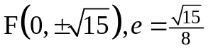 4. 2a = 18, 2b = 14, 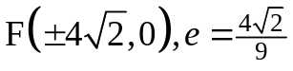
2. 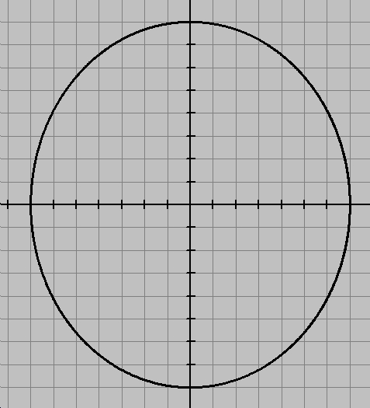 4. 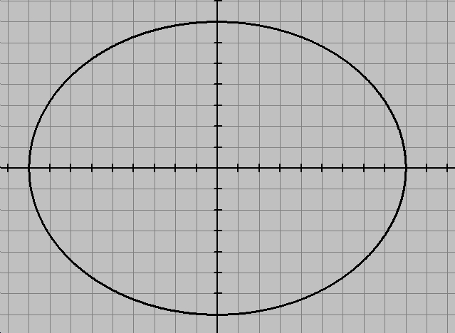 6. 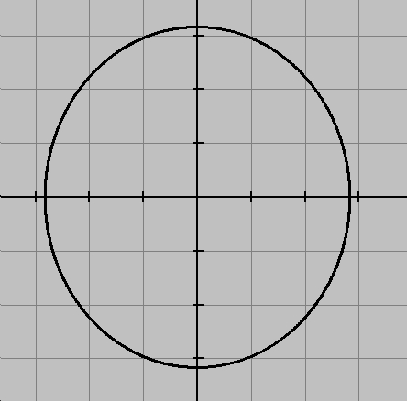 8. 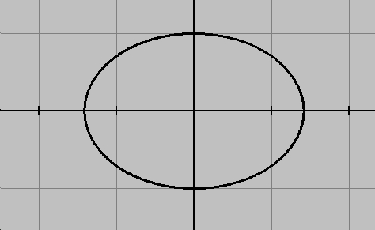
6. 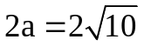,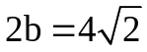,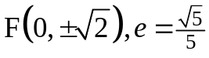 8. 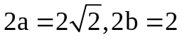,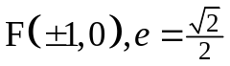
10. 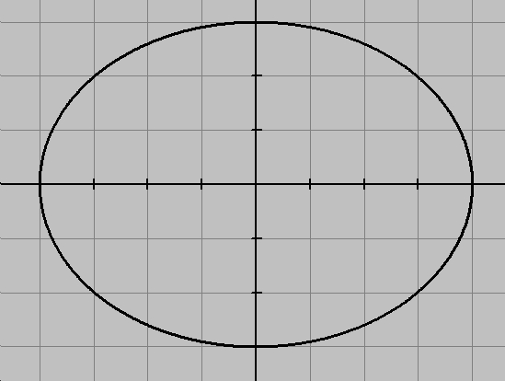 12. 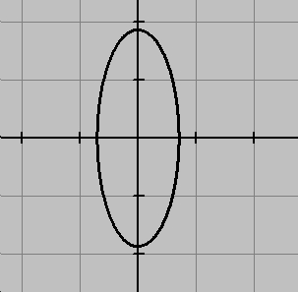
10. 2a = 8, 2b = 6, 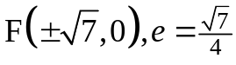 12. 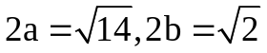,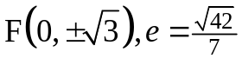
14. 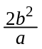 16. 154.9 million mi. 18. 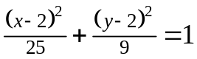 20. 459.8 million mi.
21. Eccentricity is a measure of how ‘oval’ a conic section is. e < 1 ellipse, e > 1 hyperbola, e = 1 circle.
22.C(0,4), 2a = 8, 2b = 4, 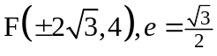 24.C(-2,4),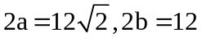,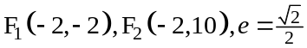
22. 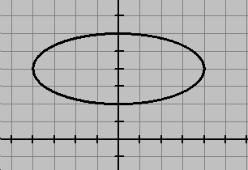 24. 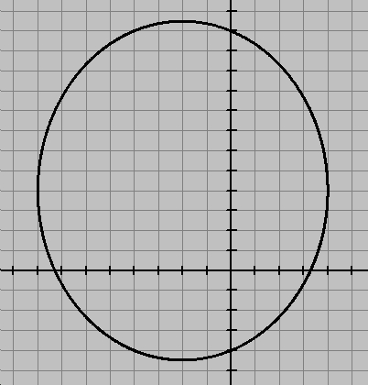
26. C(0,0), 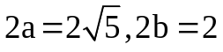,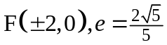 28.C(-2,-1), 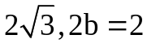,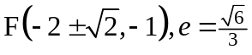
26. 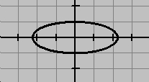 28. 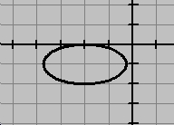
30. 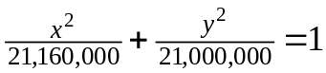 32. 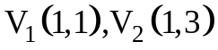 34. 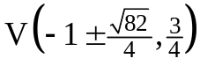
32. 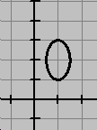 34. 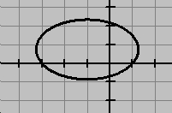 35. 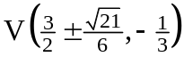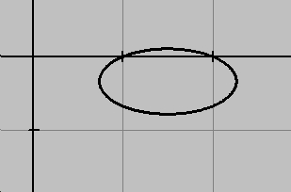
36. 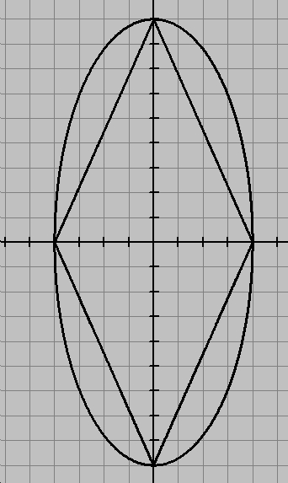 37. 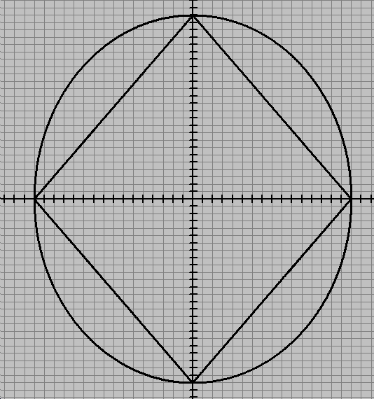 38. 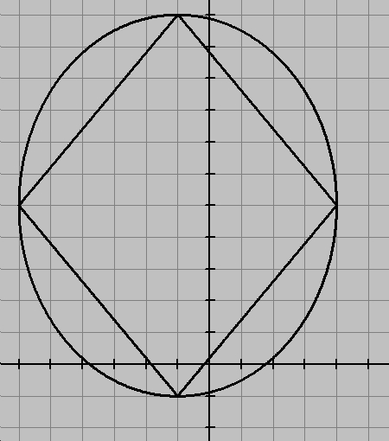 39. 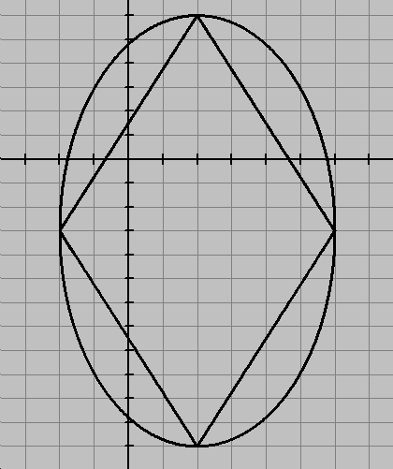
40. The waves emanate from one focus, and the patient is placed so that his/her kidney is positioned
at the other focus of an elliptical tub. (You’ll study ellipsoids later?) The reflections of the source wave concentrate at the 2nd focal point.
41. Work on both sides (Left & Right) here… (L) = 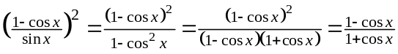
(R) 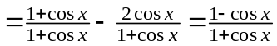 hence (L) = (R)
42. Hmm… Well, in calculus one can prove that for an ellipse: 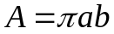, but preserving ‘relative areas’?
43. Make the target ball pass over the 2nd focal point. 44. Looks like you’ll have to complete the square?
45. 70.6 ft
Challenge 11.2
1. 6º, 3º 2. 8, 10, 12 3. 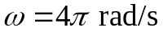, v = 43.6 mph 4. 45º, 135º, 225º, 315º
5. 90º, 270º 6. 0º, 180º 7. 40, 54, 56, 68 8. .41 inches

