Chapter 4 Sections 4.1–4.2 Even Answers (mostly!)
Section 4.1
11. [-4,4]
12. [-3/4, 3/4]
13. The ‘co’ in cofunctions like cosine, cosecant, and cotangent stands for complementary.
cos(60º) = sin(30º).
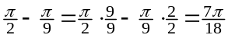
so 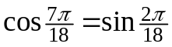
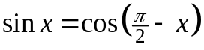
14. sin(38º)
15. Xmin = -10 and
Xmax = 10 let’s us see y-axis symmetry. Changing the Ymin and Ymax past -1 and 1 is not too useful as the range of y = sin(x) is [-1,1].

Section 4.1
Practice Exercises
2. no
4. same as y = cos x
6. right shift of 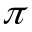
8. shrink factor ½
10. shrink factor .1
12. left shift of
13. magnify y by 4
reflection in x-axis
14. shrink y by 1/3
reflection in x-axis
15. #5 cycle, incr, decr
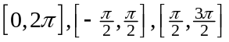
#9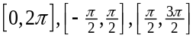
#13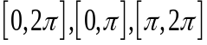
16. #6 cycle, incr, decr
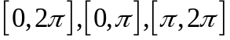
#10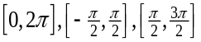
#14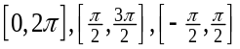
18. 9,10,12,14
20. 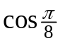
22. sin 52.5º
24. cosine is even,
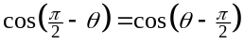 and the latter is cosine shifted 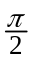 to the right which is 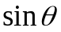. Usually, this cofunction identity is proved later using the difference formula for cosine. This answer book solution does not seem like a proof to me!
26. [-1.5, .5]
28. same period, domain, range, shape. cosine is even & sine odd
30. right-shift and an up-shift
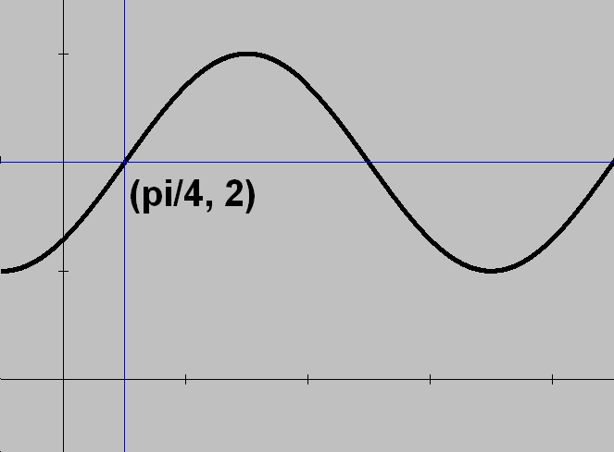
31. x-axis reflection, up-shift
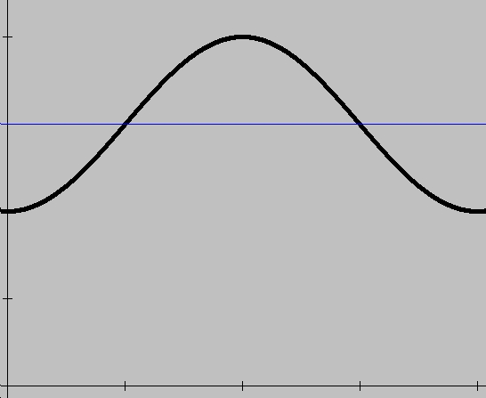
32. x-axis reflection, left-shift
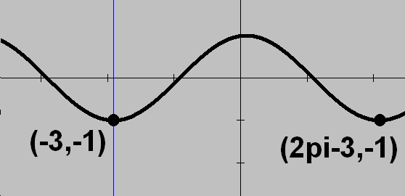
33. V-curve shifted right .5 and up .5
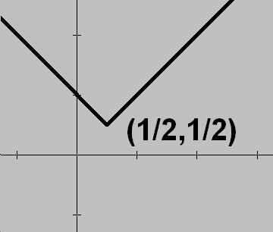
34. partial reflection in the x-axis
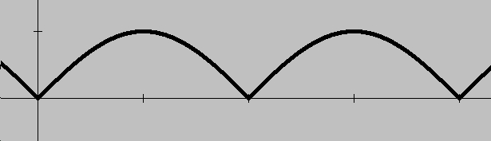
35. partial reflection in the x-axis
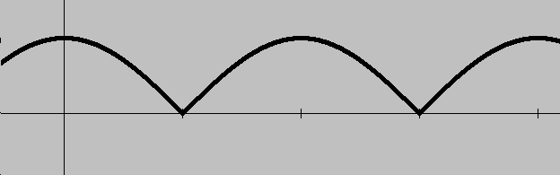
36. y-direction stretch with an up-shift
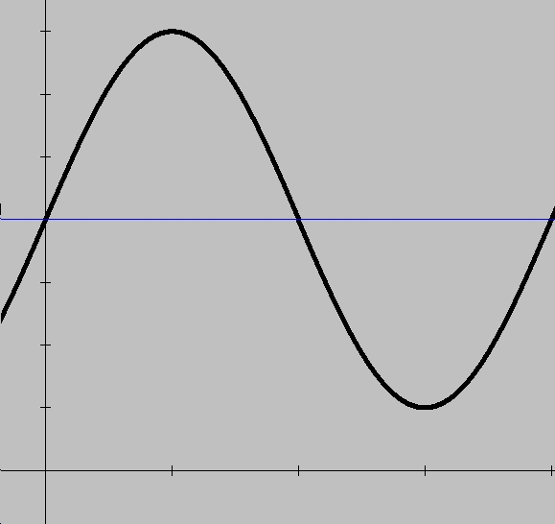
37. x-axis reflection,
shrinking in y, and then finally a down-shift
*For y = acos b(x-c) + d
one order for graphing is to work with a,b,c,d in alphabetical order.
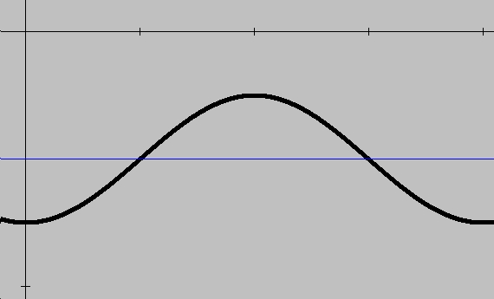
38. [1,7]
40. Graph 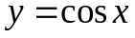
42. Graph 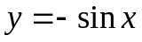
43. Sunrise, ferris wheels, pendulums

Class Exercises
1. yes, p = 2
2. yes, p = 6
3. cosine shifted up 2
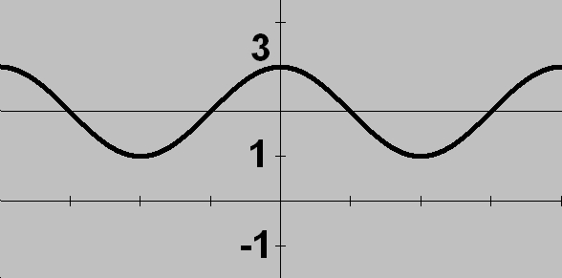
4. sine shifted right
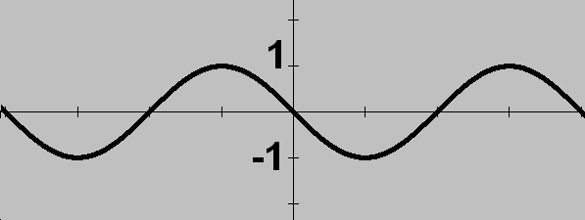
5. reflection in x-axis
6. shift units left
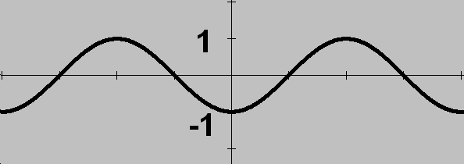
7. magnification in y
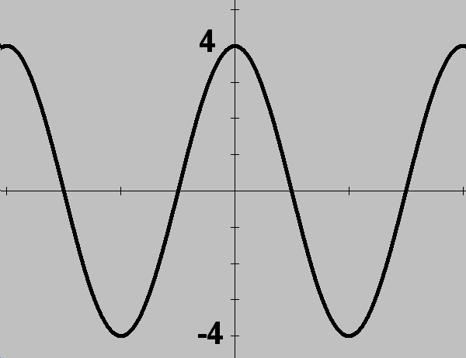
8. y-direction shrink
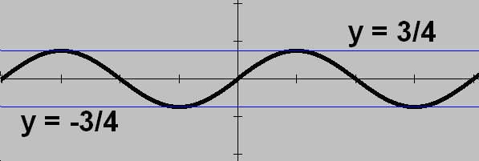

9. #3 cycle, incr, decr
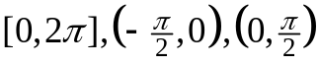
#5 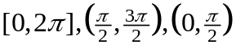
#7 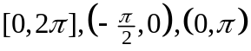
10. #4 cycle, incr, decr
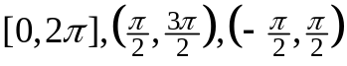
#6 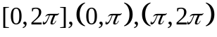
#8 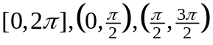
Section 4.1(continued)
44. 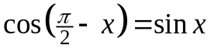
Review 4.1
1. 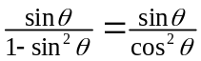
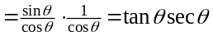
2.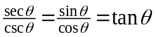
3. (x+2)(x–2)
(x+3) (x–3)
4.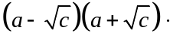
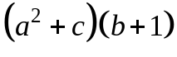
5. 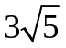
6. 72
7. 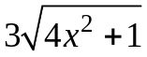
8. 64x⁴
9. 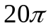ft/s
10. 2/3, -1
11. 4, -5
12. 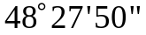
13. 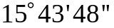
14. 189.8º
15. 6.6º
16. 1+2cos x +
cos²x –2sin x +
sin²x =
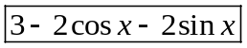
17. sec²A +
2secAcosA +
cos²A =
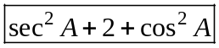
18. 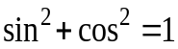
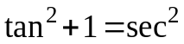 so
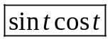

Section 4.2
Class Exercises
1. 5
2. 7.5
3. 10
4. 1.5
5. 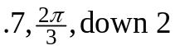

6. 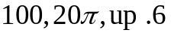
7. 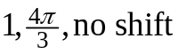
8. 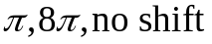
9. 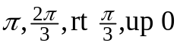
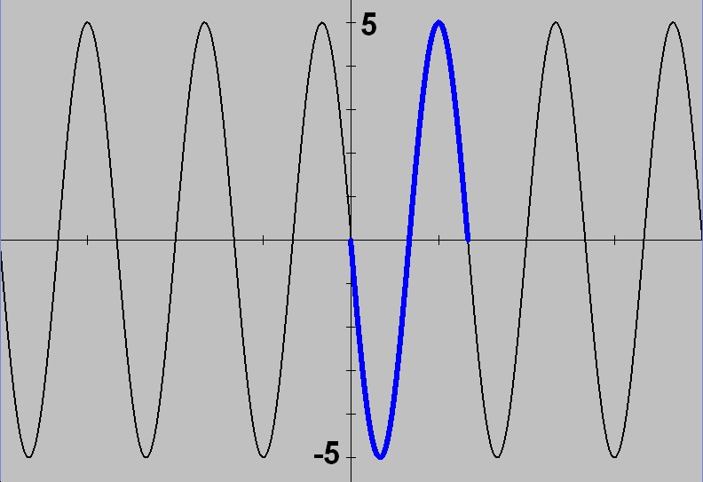
10. 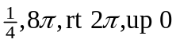
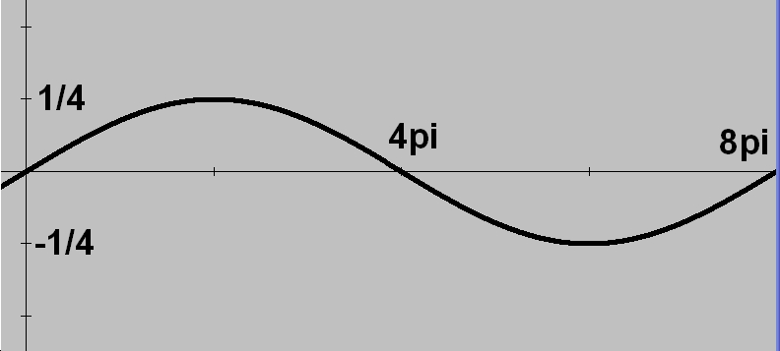
11. 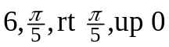
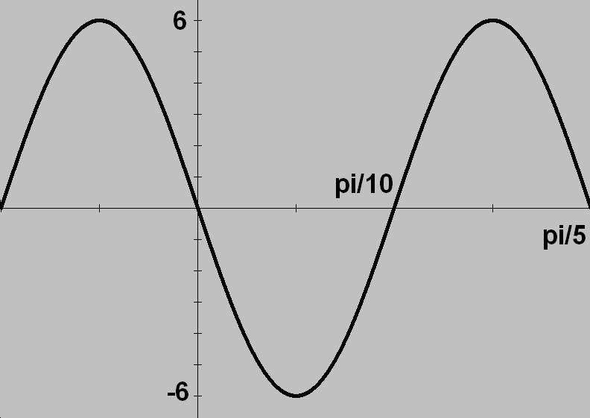
12. 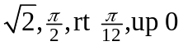
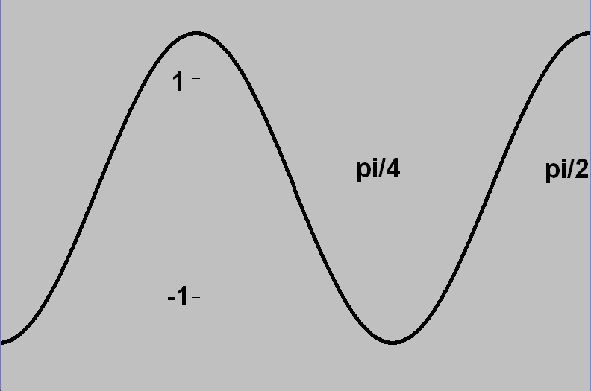
13. A sinusoid is defined as:
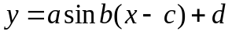
14. Max – min is a positive number. Divide by 2 to get the amplitude or |a|.

Section 4.2
Practice Exercises
2. 1
4. 1
6. 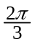
8. 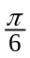

10. 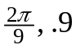
12. 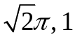
13. 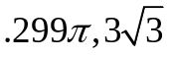
14. 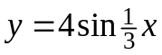
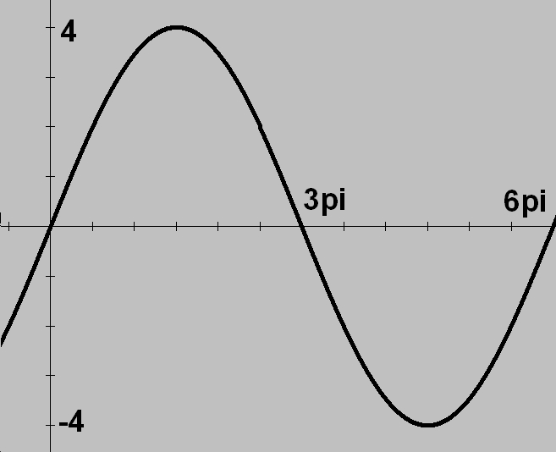
15. 15
16. 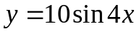
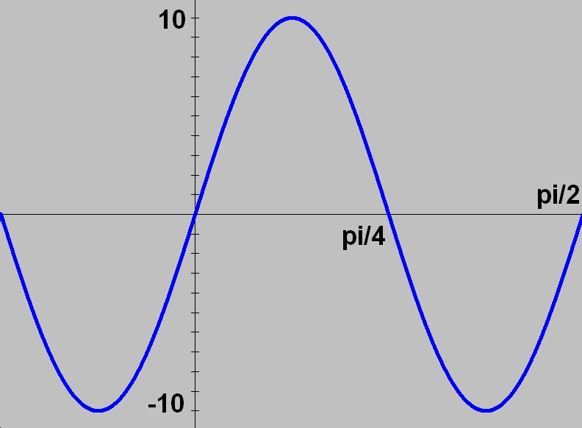
18. vertical stretch 5
right shift
20. 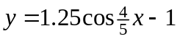
22. 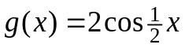
26. 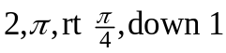
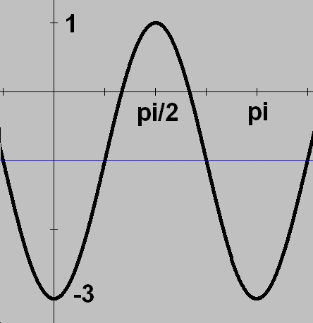
27. 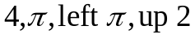
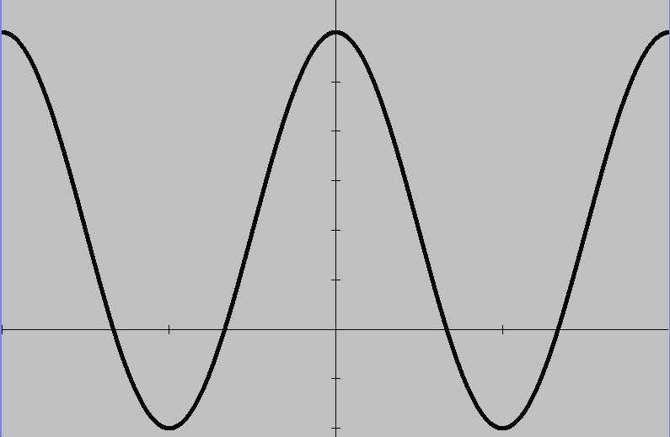
28. 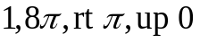
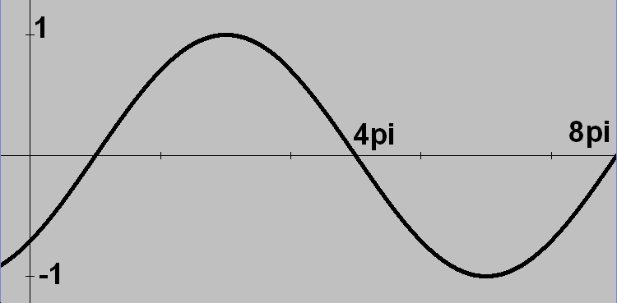
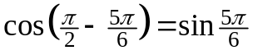
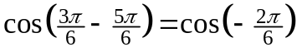
= 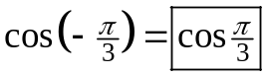
An easier way might have
been to draw a quadrant II
right triangle.
45. 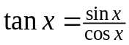
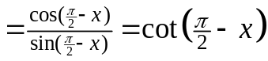
46. 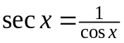
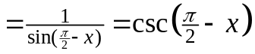
47. Again, this proof is
usually left as an exercise
after we learn the sum and
difference formulas for
sine and cosine. (Later!)
48. 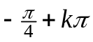
49. 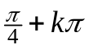
50. f(|x|) is EVEN!
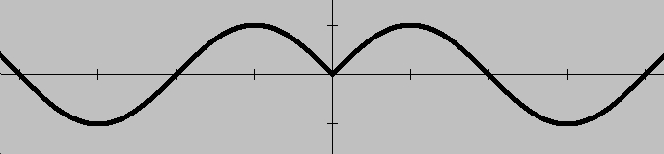
51. cosine is already even!
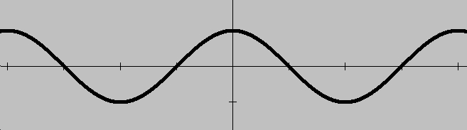
52.
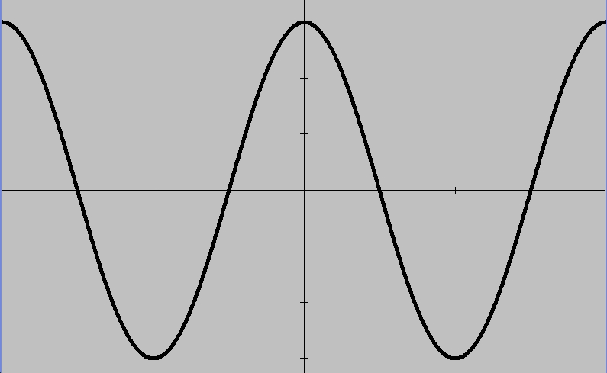
53.
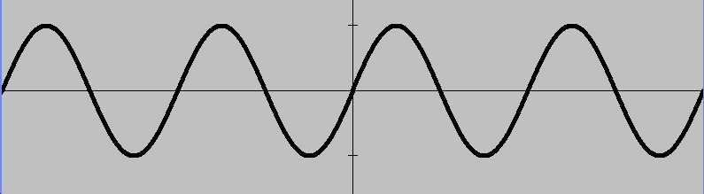
54.
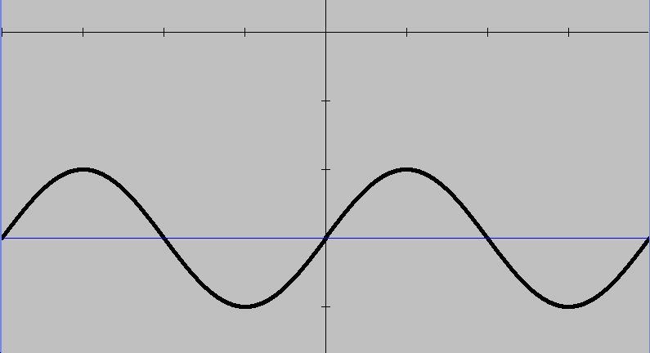
Section 4.2 (continued)
29. 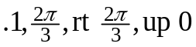
33. zeros (y = 0)
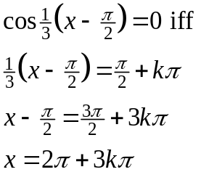
minima: y = -3
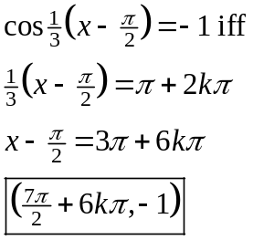
maxima y = 1
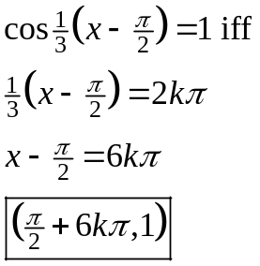
34. pedal on a bicycle, circular motion in general, oscillating spring-mass system
36. y = 1/sin(x)
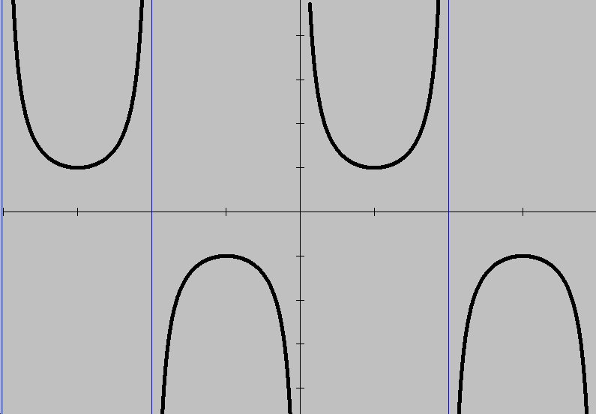
no amplitude
38. 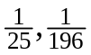 and the time period (T) is the reciprocal of the frequency (f), so 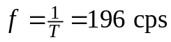 Cycles per second in SI units is Hz (hertz).

40. 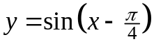
42. 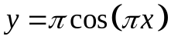
44. 10V, 1/60 sec
46. f.p. = 1
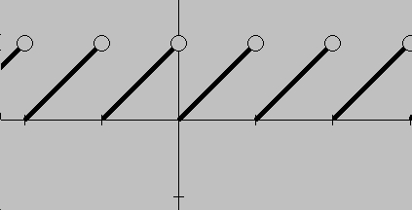
47. 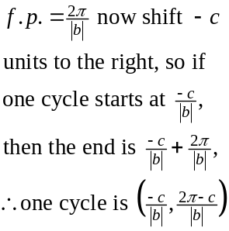
48. Note the use of braces {0,0,2} to have the calculator graph 3 graphs with those values.
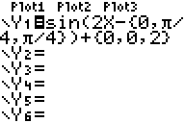
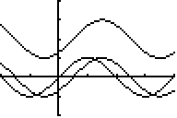
Try graphing:
Y₁ = {-1,1,3}x²
49. 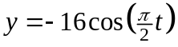
50. 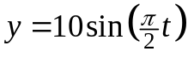
51. 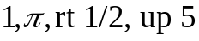
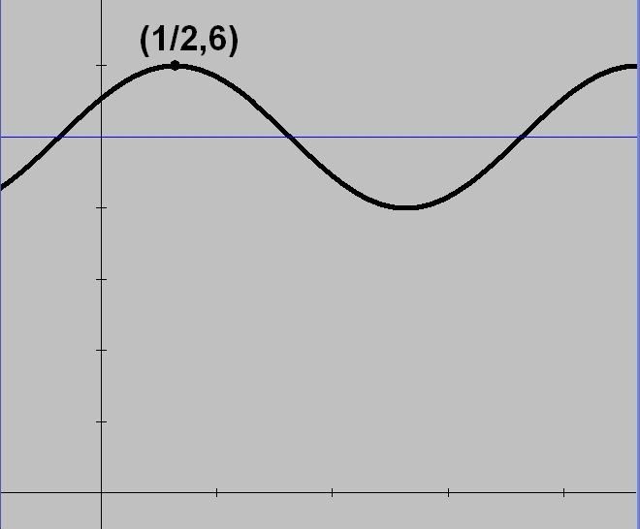
52. 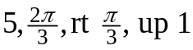
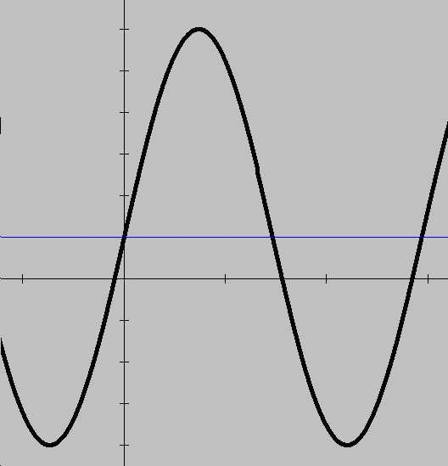
53. 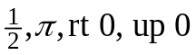
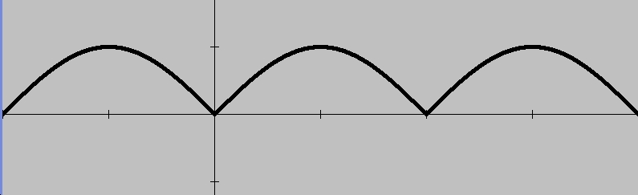
54. 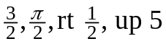
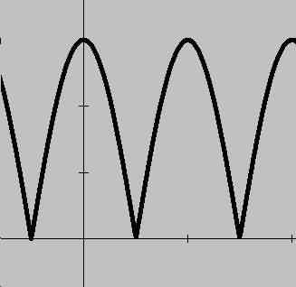

Challenge 4.2
1. 581 ft
2. 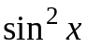
3. 3
4. 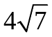

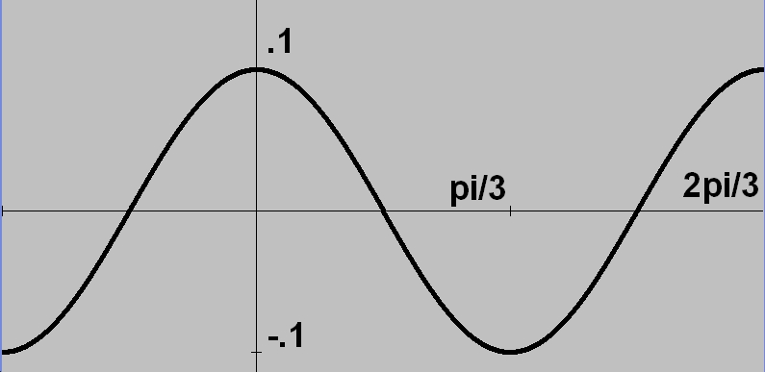
30. 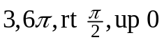
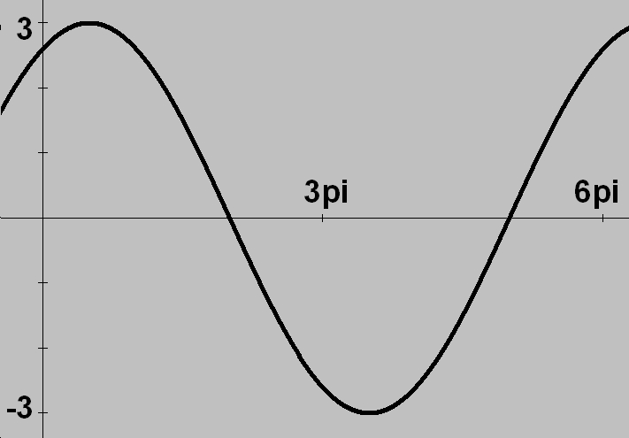
31. 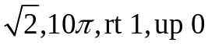
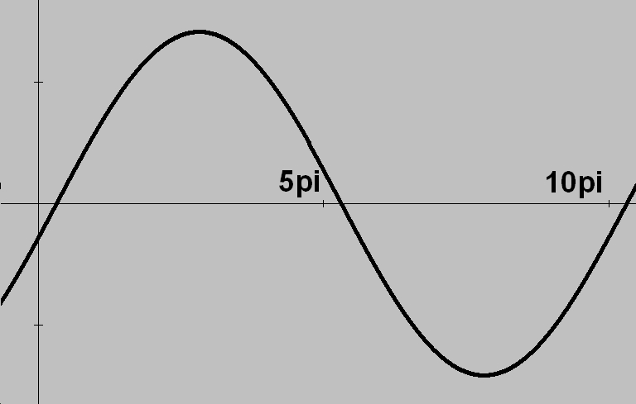
32. Zeros when y = 0
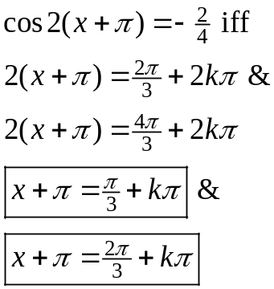
Since R = [-2,6]…
minima when y = -2
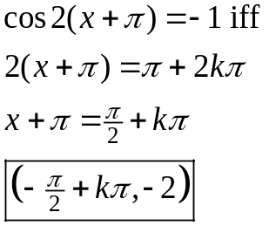
maxima when y = 6


