Chapter 8 Sections 8.1–8.3 Even Answers Mostly!
Section 8.1
26. 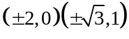
28. (-2, 4)
30. (2, -2)
32. (-1, 2)
33. x = 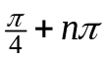
y = 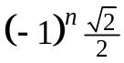
34. 9.5%
38. (4, .25)
40. (.9, 1.1)
(-.9,-1.1)
42. 20 oz of 90%
30 oz of 30%
solution
44. The graphs can be deceptive when the 2 graphs are very close.

Review 8.1
1.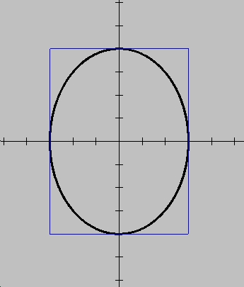2.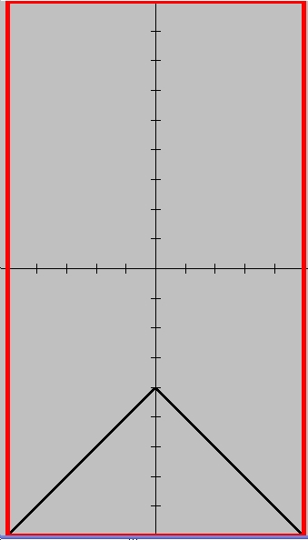
3.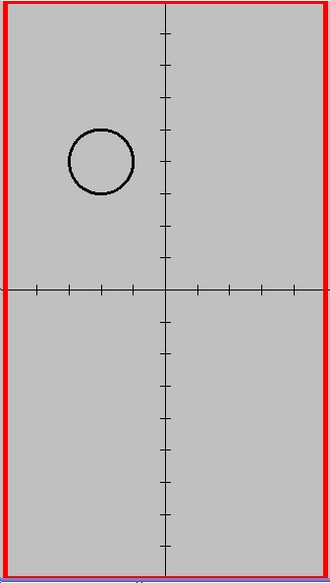4.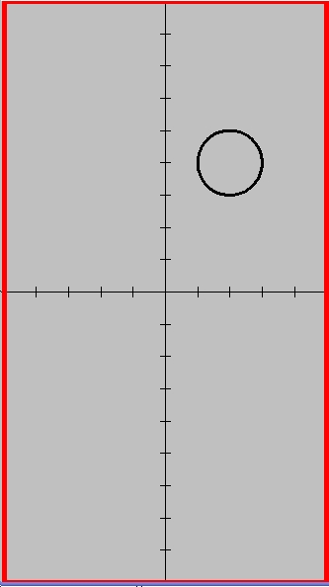
5.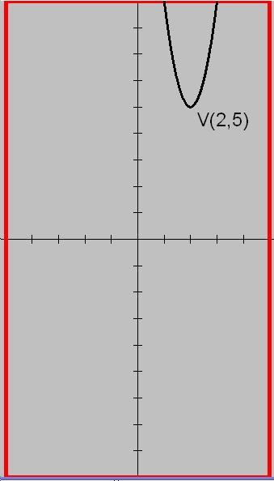6.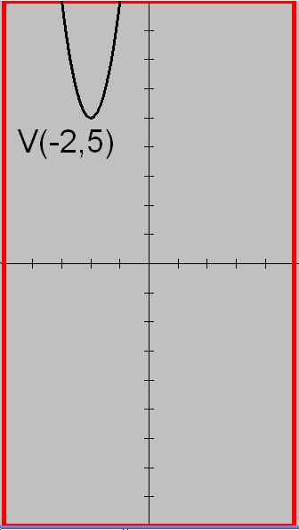
7.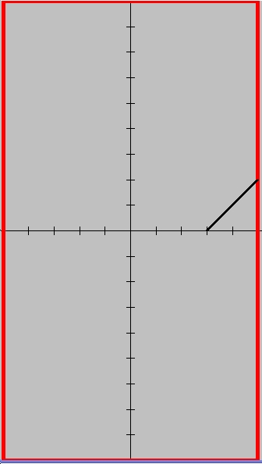8.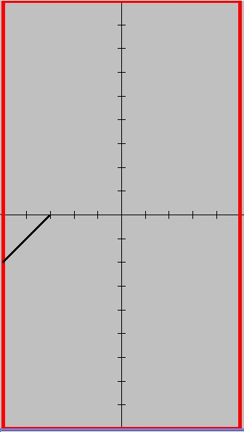
9 & 10.
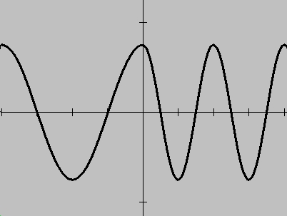
Section 8.2
Class Exercises
1. 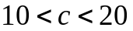
2. 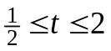
3. 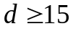
4. 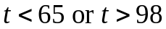
5. 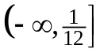
6. 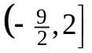
7. 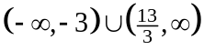
8. 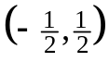
9. dotted (dashed) 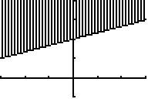
10. solid line 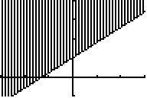
11. solid line 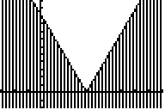
12. dotted line 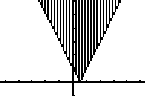
13. Also graph the horizontal line: y=68.
By inspection, select the C-values (x) where F lies above that horizontal line.

Section 8.2
Practice Exercises
2. 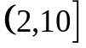
4. 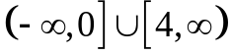
6. 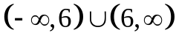
8. Most would just say no and prove it with a counterexample. BUT… consider a & b as x-coordinates with
a < b (a left of b)…
Now graph y = x² and see if when a < b, a² < b² (check the y-values!) See the graphs below.
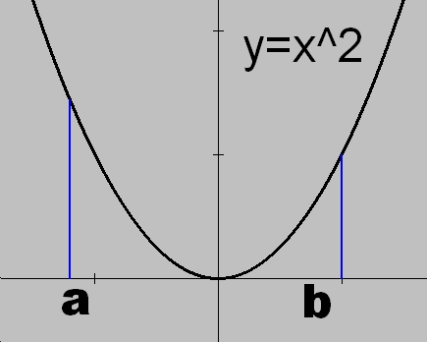
10. solid line
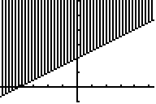
11. solid line
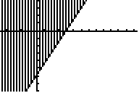
12. dotted line
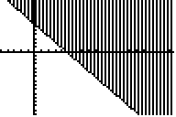
Class Exercises
1. (-17, 8)
2. (-1.2, -7)
3. (-1, 1)
4. (-1, -1)
5. (-1, 2) (2, 5)
6. (-4.61,2.81) (.11, .45)
7. Use Zoom & Trace
8. d_{tortoise} = 100t + 1000
d_{Achilles} = 1000t
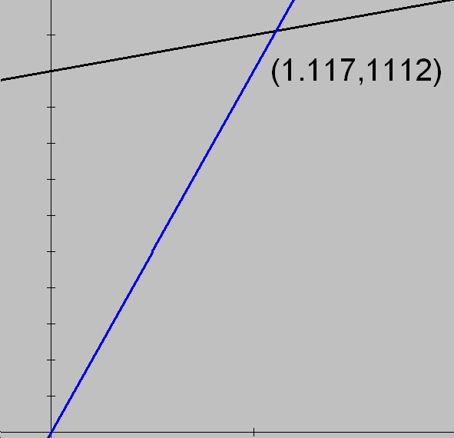

Section 8.1
Practice Exercises
2. 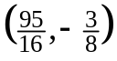
4. 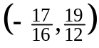
6. 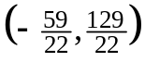
8. 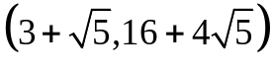
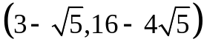
10. (-1, 0) (2, -3)
12. certificate $3200
bond $1800
14. equivalent equations,
coincident lines
16. plane: 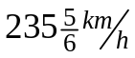
wind: 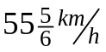
18. x = 50, y = 28 ft
x = 52.4, y = 23.2 ft
19. Generally, only
approximate solutions
can be found.
20. (10.7, -6.8)
22. 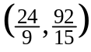
Section 8.2 (continued)
13. solid line
32.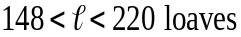
33. “V” shifted left 2
34. at least 72 days
35. “not gonna do it!”
36.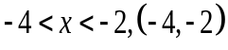
38. 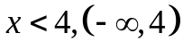
39. 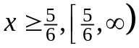
40. 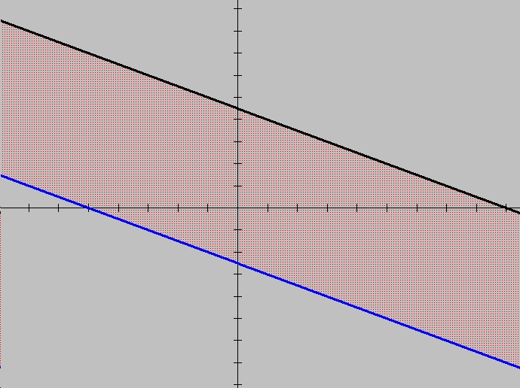
41. 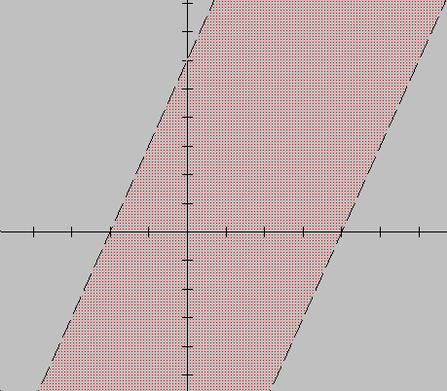
42. 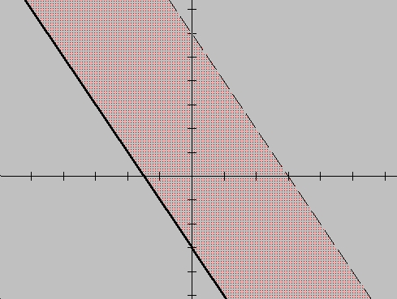
43. 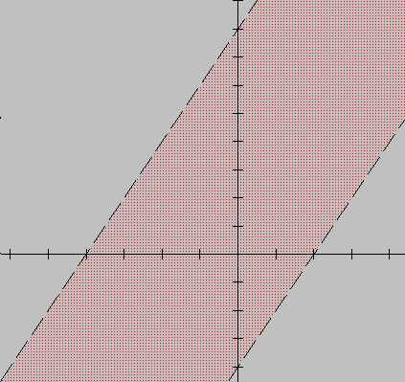
44. (65,90)
46. 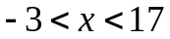
Challenge 8.2
1. y > 0 or y > –2x
2. 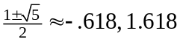
3. four: 2,3,5,7
4. m is odd
5. 1
6. 48
7. 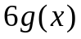
8. 37
Section 8.3
Class Exercises
1.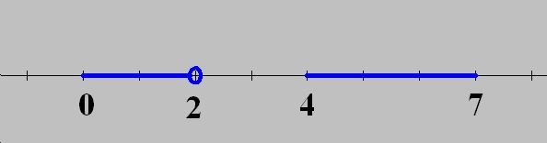
2.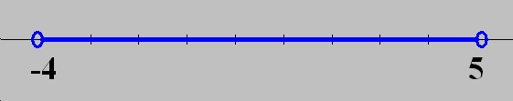
3.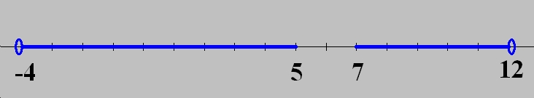
4.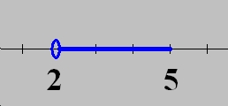
5. x = -3
6. x > 0, x < -2
7. 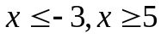
8. 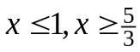
9. 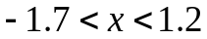
10. solid line
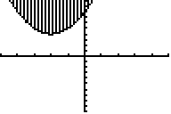
11. dotted line
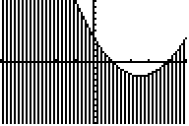
12. 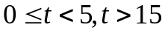

Section 8.3
Practice Exercises
2. x = 4
4. x < 0 or x > 5
6. -1 < x < 1/3
8. 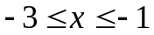
10. Concave up & above the x-axis.
12. 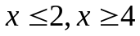
14. -3 < t < 3
16.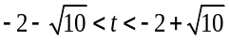
18. solid line
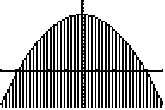
19. dotted line
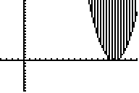
21. empty set since the curve lies above the x-axis

22. x > 14.26 h
24. 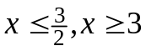
26. 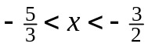
30. 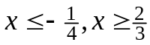
32. 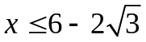,
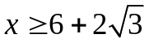
33. dotted line
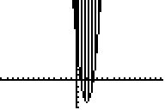
34. solid line
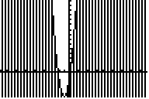
35. dotted curve
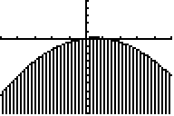
36. If a < 0 then concave down and 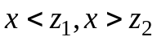. If
a > 0, then concave up and 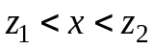.
38. more than 1.78 ft
40. 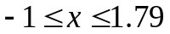
42.(x + 3)(x + 2) < 0
44. ex 1/ -x² – 3 < 0
ex 2/ -x² + x – 4 < 0
46. x < -1.6 or x > 1.6
Review 8.3
1. 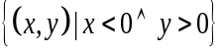
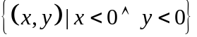
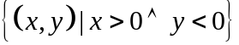
2. 10

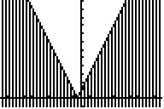
14. dotted line
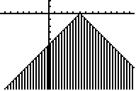
16. less than 140 mi
18. more than 9 h
19. Dow Jones,
LA temperatures,
legal parking distance from
the curb, my height range,
temperatures above 100º
and below 0º
20. – y > x + 1
22. 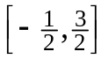
24. 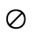
25. 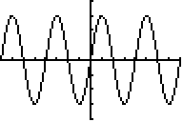
26. 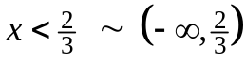
28. 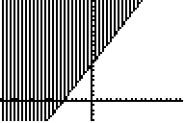
29. overlap or intersection
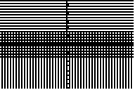
30. I: x>0, y>0 II: x<0, y>0
III: x<0, y<0 IV: x>0,y<0

