*Solve for 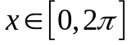 & sketch the graphs Trig Inequalities with Calculator – 1.0c
1. 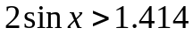  2. 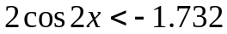 | 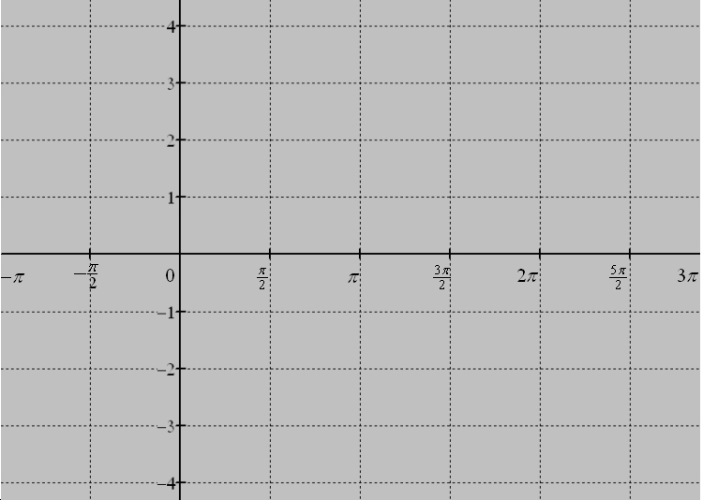
3. 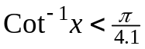  4. 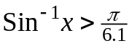 | 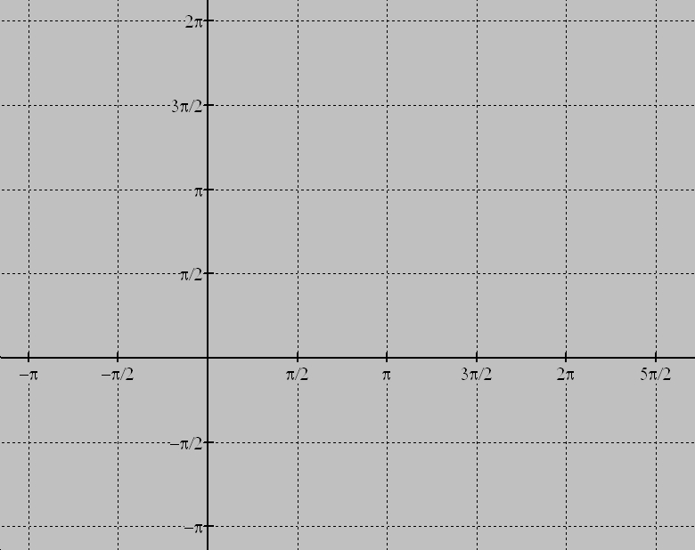
5. 

6. 

