POTPOURRI (Return to T.I.)
As I grew up, one incident left a lasting impression on me, and I learned a lesson of compassionate human behavior. I must have been about 6, about the time the city workers were dredging the First Beach area. Hisashi Harvey Hanamura gave me a model of a boat he had started to carve out of a piece of redwood. At any rate it must have been a great sacrifice for him. Later he became my dear friend and mentor. As of this writing, I have yet to argue, raise my voice, or disobey him. Just ask his wife, Kiyo.
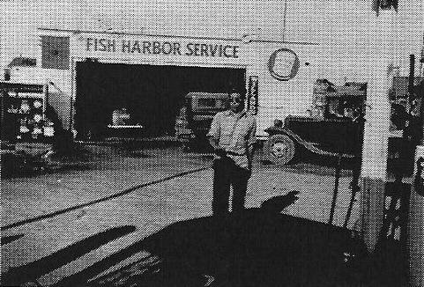
Harvey Hanamura’s service station (circa 1939)
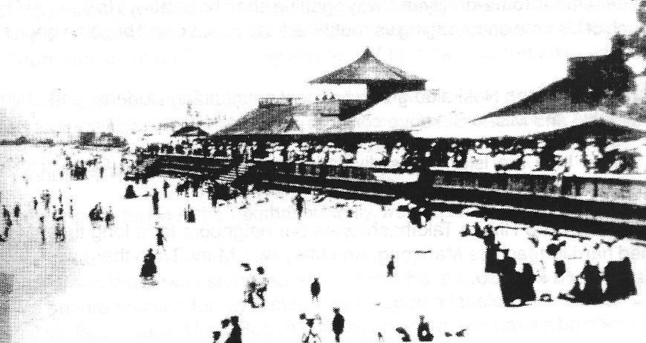
Brighton Beach
When it came to swimming, besides jumping off the wharfs or boats, the swimming spots were First and Second Beaches and Brighton Beach. By the time I was old enough to enjoy the splendor of the beach hotel at White Point, the bath house and pavilion were gone.
Many other memories remain vivid. I can still picture my mother pounding rice with the wooden mallet with George Fukuzaki as her partner, preparing for the New Year. The rest of us were too small and the menfolk were out fishing. About this time, George’s sister, Ta-chan, was just learning how to bake. Ta-chan and Yoneko Marumoto would bake cookies on the weekend and we kids were the tasters. Those cookies were terrific.
Miss Burbank, our kindergarten teacher, was one tough lady. We learned to respect and obey her quickly. Twenty-five years later when I opened my dental practice in San Pedro, she called to congratulate me. It’s funny how the rowdiest student is almost always remembered. Not too many remember Miss Chan, our other kindergarten teacher.
The girls in my elementary classes were all very nice. Very quiet and so obedient. Perhaps growing up in a male-dominant society influenced them. However, I am certain that among themselves, these same girls were mischievously having their own brand of entertainment and fun. No doubt with lots of giggling.
The best girl athlete in our group was Sadako Yoshida. She could really run and jump. I know she could have easily out-run me.
Remember Toma-no-jiiyan always getting after the bad boys to behave? He dedicated much of his time encouraging us roughnecks to behave and become good students and citizens.
In my time, the Hokkaido group had few outstanding students and athletes. Harumi Nakasaki and Misao Sakauye come to my mind.
Funny how the island was divided into the Tuna Street Gang, Hokkaido Gang, Southern Cal Gang, and the Cannery Street Gang.
Setsuko and Hiroko Takahashi were our neighbors for a long time. Mrs. Takahashi tried hard to teach us Mah-jong. And Mary was Mary. Then there were the quiet boys, Ken-bo and Fum-bo.
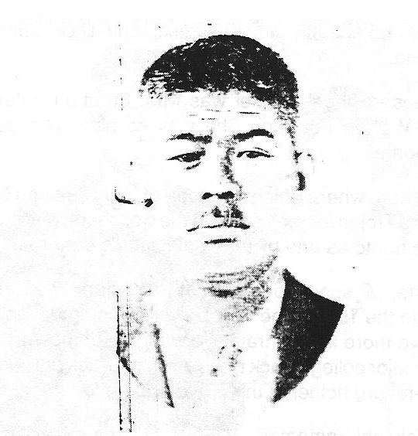
Mr. Torao Takahashi (Courtesy of Mr. Takeuchi)
Mr. Torao Takahashi was the epitome of the fishing captain, a burly, tough man and a kendo-man. After the war, California state law denied him the right to engage in commercial fishing. The Takahashi case is a landmark legal case which re-established the right of lssei to engage in commercial fishing. He won the class action lawsuit but lost the case in Appeals Court on Jan. 16, 1948. Mr. Takahashi then took the case to the Supreme Court, and on June 7, 1948, by a vote of 7 to 2, he won the final decision.
Another fisherman was Mr. Katsusuke Hamachi. He was known as the pioneer who discovered sardine fishing in northern California, from San Francisco to Astoria, Oregon. Even the Slavonian fishermen acknowledged and recognized his contribution to the sardine industry. They loved and adopted him as “Katsu.”
Our other neighbors, besides the Takahashi family, were the Fukuzaki, Ige, Fukuhara, and lshii families.
During the Korean War, I was stationed at the Zama Hospital outside of Yokohama. Searching for private housing for my family, I came upon a landlord in Yokohama. As soon as I saw his face, I said, “Stop. Before you say anything, you have a brother, Hugo Mahr, assistant manager of California Bank in Terminal Island, so your name must be Mr. Mahr.” I had run into Mr. Mahr’s older brother. There was a terrible housing shortage in Japan at that time and I was in a desperate situation. Naturally after answering all his questions about his brother, Hugo, I got the rental unit. When I returned to the States, another Terminal Island family, Kazuo Okuno and his family, moved into the unit. I also bumped into Ken-bo Takahashi, Jim Fukuzaki, and Dick Shiroyama while I was stationed in Yokohama.
My favorite Japanese School Sensei was Mrs. Furutani, related to the Board of Education member, Warren Furutani. She was so nice, very reserved, and never scolded us noisy students.
I became a USC fan when Shingu-sensei of our Seisho-Gakuen took Hiroshi Yamamoto and me to a Trojan football game at the Coliseum. Many of you will remember Hiroshi “Beans” Yamamoto as one of Terminal Island’s better athletes.
Talking about sports, we should be proud of track stars Yasuo Tatsumi and Kiyoshi Sakimoto. Kiyoshi ran the 100 for the very powertul Compton College track team. It’s too bad he didn’t have more time to train. He was one of the very few Nisei to run the 100-yard dash for a major college track team. Another track star was Tsuneo Kuramoto who was the city co-record holder in the 50-yard dash for a very long time.
Too bad we lost Takashi Yamamoto to kendo. I wonder how much he would have accomplished in sports if he had continued at San Pedro High and possibly in college. His younger brother, Satoshi, was a long jumper at San Jose State College when Satoru Kohigashi and I were at Berkeley.
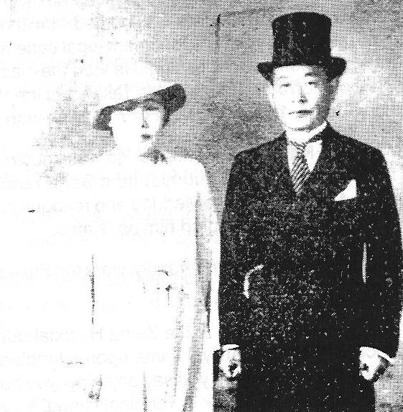
Mr. and Mrs. Kyoichi Okuyama
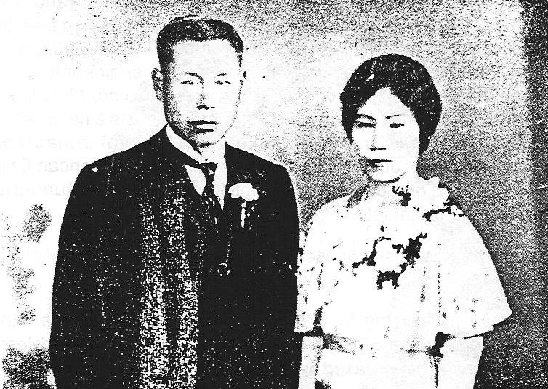
Mr. and Mrs. Kobei Tatsumi
Not many Nikkei communities read “Kyoiku-Chokugo” as part of a community event. Many Nisei have no knowledge of it. In Terminal Island we were fortunate to have Mr. Kyoichiro Okuyama read “Kyoiku-Chokugo” every year in the month of April, coinciding with Emperor Hirohito’s birthday. He would always be dressed in striped pants, tails, and top hat. As I understand it, the document stresses being a good and obedient citizen.
I must have been about 10 when I walked by Fisherman Hall where a big funeral service was being held. As I saw all the people attending the service, it dawned on me that it was Yuki Tatsumi’s father’s service. L thought to myself that Mr. Tatsumi must have been quite a man to have so many people pay their respects. I’m sure it was the biggest funeral ever on Terminal Island.
What about Mr. Kinoshita of Kinoshita Boatyard and his big sedan? I would often see him drive down Barracuda Street wearing a cover-all with a big cigar in his mouth. I’d bet he was the only lssei to own a Duesenberg convertible sedan.
Our small Japanese fishing village of fewer than 2,000 people should be proud of many of our older Nisei. We had three Stanford University graduates. They were Ernest lshigaki (Asao’s older brother) in electrical engineering, Dr. Shigeichi Okami in medicine, and Mr. Yokozeki in economics. Mr. Kanichi Kawasaki graduated with a master’s degree in sociology from the University of Southern California. Dr. Fred Fujikawa graduated from Creighton Medical School and Drs. Yoshio Nakamura and Yoshio Nakaji graduated from USC Dental School. Mr. Nobuo Nakamura graduated from the Department of Aeronautics at Santa Monica College. He returned in 1937 to Japan to work for Mitsubishi Heavy Industry, Ltd., where he was a key design engineer for the Japanese Zero fighter plane. Mr. Takeuchi has compiled and preserved our historical data. Gyo Fujikawa is the author and artist of many children’s books and is a nationally renowned artist. Mr. Fred Wada (known as Mr. Olympic and also as Mr. Keiro) is one of Los Angeles’ foremost philanthropists; Mr. John Shigeru Nitta founded the American Chick Sexing School; and K. Yamamoto graduated from a Baptist seminary and returned to Terminal Island as our own Rev. Yamamoto.
If we included the younger Nisei, Sansei, and even Yonsei,the list would be terrific and impressive.
The carefree days of roaming from one corner of the island to another and of swimming in the harbor and at the First and Second beaches were priceless. Building those intricate caves at the beach taxed our imaginations, and the Tuna Street Gang had the best cave.
“Borrowed” hot sardine cans, fresh out of the giant cookers outside the fish cannery, were delicious and appreciated by our gang. One of the fellows would run home to get a can opener, and we would find an empty freight car to take the treasure. There we would feast native style, using our fingers.
One of our biggest arguments was who made the best snow cone — Kintoki with azuki. Was it Ben Sweet or Mr. Hamashita’s grocery store?
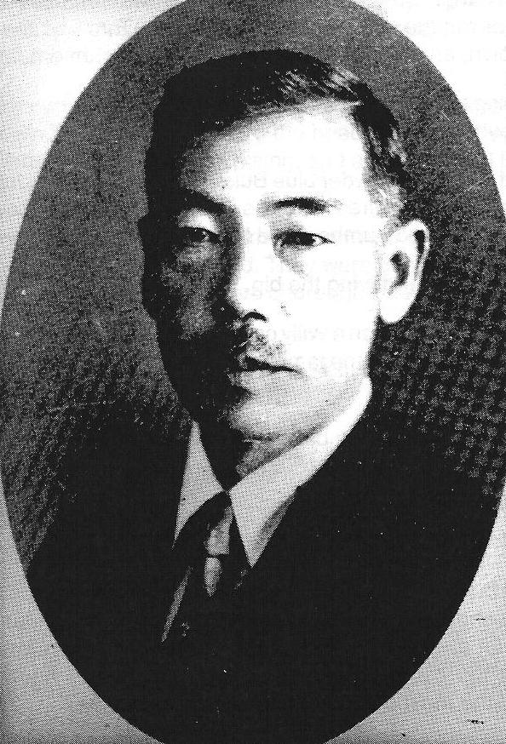
Mr. Otoji Hara
Mr. Otoji Hara was my classmate lwao’s father. He was our “gentleman” from Terminal Island, respected by all and a classy man. Who would have thought I would later meet the Hara and the Fukuzaki families in Gunnison, Utah, a small town without paved streets? George Fukuzaki and his wife invited my wife and me for a delicious pheasant dinner.
Yukio Tatsumi is a little younger than me, but he stays young and energetic. He has done a lot for the Terminal Island Club, and I am privileged to claim him as one with whom I grew up.
Frank and Nakako Takeuchi should be proud of the accolade given to their son, Dr. Stuart Takeuchi, a vice chancellor for Administration at the University of Colorado. Dr. Stuart Takeuchi was elected president of the Association of University Related Re search Parks. The 290 members of this elite and prestigious group represent 80 percent of research parks in North America and 18 countries.
Toma Grocery Store was one of the larger ship chandlers on Terminal Island, and they also had a Japanese bookstore. Many of us depended on the Toma Store for the complete Mochi-tsuki equipment, and the store loaned its trucks for community use. Dr. Okami and Dr. Nakaji occupied the second floor above the store for their practices.
I have often wondered how George and Mr. Mio found us after Manzanar in Germantown, Pa., where we had relocated. Mr. Mio could not attend my father’s funeral in Manzanar a year earlier, so he had driven from upstate New York to pay his respects. Before Germantown, while in Philadelphia, we found ourselves in the same apartment building as the Matsutsuyu family.
I met the Okamoto families in Seabrook, N.J., an unlikely place to have a reunion. I also met Frank Takeuchi here. Wataru Okamoto and his wife put me up at their place for about a week. I feel bad that I never fully thanked Wataru.

Did you know that O.K. Market used to be the Tanishita Grocery Store? Tom Tanishita’s father ran the store for quite some time. Tom was the strongest fellow that I have ever known, and he never lifted weights. He just had natural strength.
Talk about being strong, if I ever get caught in a back alley, I want Koshi Seko and Yachi Shirokawa at my side.
Junji Tani and his sharp powder blue Buick was quite a sight. Junji would always take the corners with screeching tires. Once he, in his Buick, and I, in our family’s Olds 8, drag raced from the Hammond Lumber Yard to the Ford Drawbridge. Guess who won?
Ichi Hashimoto’s father driving the big, powerful Reo, was an impressive sight.
Mrs. Kisaye Tsuchiyama won a Willy car in a raffle one year. I believe the car was called “Knute Rockne,” named after the famous University of Notre Dame football coach. Can anyone verify this for me?
Guys must remember playing ball against the Terminal group with Joe and Stanley Legaspi and Walt Chartier as the catcher.
A nostalgic landmark was Chartier’s Gilmore station with its colorful Red Roaring Lion gasoline logo. Joe and Walt Chartier were terrific friends of the Islanders.
When I was at the San Pedro Booster Club early in 1950 with Art Nakahara, it was nice to talk with high school coaches Karl Haney, HollyAdams, and Manuel Laraneta. Coach Haney talked a lot about Dr. “Lefty” Nakamura and Hiroshi Yamamoto and also Ichiro Koda, who was the catcher for the baseball team. Holly Adams’ favorite was Ray Matsushita, and the most popular player was Shig Nakaji.
The judo group once put on a program at the Fishermen Hall that I will never forget. I must have been about 14, and I can’t believe what I did, but at this age, I just did what my elders told me to do. With bamboo castanets and dressed in “yukata,” I was in the chorus, doing my thing on a large “geta” (wooden clodhopper) dancing to the music of “Tokyo-ondo.” It must have been a fund-raiser. Some of the fellows sang Japanese songs, and Toshiro Izumi was involved in a harmonica duet performed by the Sakimoto brothers.
The kendo group under Fujii-sensei was a strong group. This large and popular bunch must have been one of the stronger teams in California. I remember Bunkichi Hayashi and Hiroshi Yamamoto as two of the top fencers. Following them were fellows like Frank Takeuchi, Henry lida, and a large number from my peer group.
Gregory (Mackey) MacDonald, a fellow Terminal Islander, worked as an engineer on the Patriotic for a very longtime, and Dad really liked him. Every year after tuna season, the crew would have a party at a chop suey restaurant in San Pedro, and each crew member would sing a solo. Mackey would always sing “Hato-po-po” (Pigeon) in very good Japanese. Did you know “Hato-po-po” was written by a person in Shingu-shi, Wakayama-ken? There is a statue of a pigeon in the city square. When you drop in a coin, the pigeon sings the song.
I remember Mr. Tomekichi Ozawa and his airplane. I can still picture a bunch of guys pushing his plane down Terminal Way toward the beach. I believe he eventually was able to become airborne. Anyway, it was exciting, and all of Terminal Island was there to cheer him.
Emi Mio, Mitsuko Hashimoto, Misuko Nakamura, and Yuriko Tsutsui were the premier performers of Nihon-odori on Terminal Island. They were good and often performed at the Fishermen Hall. Some of the dances were choreographed by Mr. Kobata, father of Tadao Kobata.
Tadao Kobata was our movie projectionist during our elementary school days. Remember the cartoon “Felix, the Cat”?
The class below me at San Pedro High School had a group of smart girls— Kayo Asai, Chizuru Nakaji, and Hiroko Takahashi. All three graduated with California Scholarship Federation honors. At that time, it was special for three Nikkei girls from one small class to attain such an honor. Another scholar and athlete was Ritsuko Miyoshi. I wish I had more information about girls for this book. The society on the island was different during the pre-war days, and it didn’t contribute to the mingling of the sexes.
Toshiro Izumi and Yumiji Higashi continued their Nihon-Gakko education. Toshiro would rank at the top of an elite group of Nisei who are accomplished in the Japanese language without the benefit of schooling in Japan. Another top student was Kisaye Nakasaki Sato.
The group of Bob Uragami, Moto Shimizu, Kiyoichi Paul Ryono, Tokio Hayashi, and Mas Tanibata made a terrific basketball team. Their average height was 5-feet, 10- inches, and tallest was Bob Uragami who was over 6 feet tall.
Lt. Col. Kanshi Stanley Yamashita of the U.S. Army and Dr. Yoshio Nakaji of similar rank in the U.S. Navy were two high ranking officers from our tiny fishing village. Dr. Nakaji probably was the highest ranking Nikkei officer in the Navy. The oldest son of Ryoji and Hiroko (Takahashi) Nonoshita, Wayne, was a Naval Academy graduate.
lwao Fred Shirokawa, one our more prominent Nikkei pioneers, was the key in forming the Terminal Islanders Club. He was always Shirokawa-san to me. He loved to play poker and would never miss his monthly poker session with my older brother and mother. I never saw Shirokawa-san draw to an inside straight. I used to tell him that would make his game more versatile. Maybe I was wrong; he won more often than I did!
Shig Nakaji left an impressive reputation with the Garcia Mitchell Fishing Tackle Co. as an expert fishing pole designer and maker.
Yutaka Dave Nakagawa has been doing wonderful work with a Christian youth program for a long time.
My message, very humble, to the energetic leaders of the Terminal Island Club, Yuki, Mas, and Toshiro: I hope strong steps are being taken to perpetuate the existence and well-being of our Terminal Island Club.
Who on the island had a better smile than Mr. Matsutsuyu?
Whatever happened to Katsumi Okuno who grew up in the Hokkaido section? Post war, he did very well in the container business.
The bunch of Tiger, Koshi, Naka, Saburo, and Charlie 0 are quite a group. They must be the core of the Terminal Island “Yogore.” I use this word with their permission. Of the bunch, I imagine Charlie Hamasaki is the most versatile and Tiger the most popular.
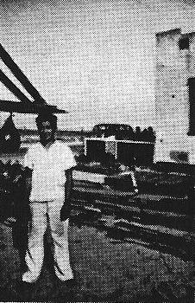
Kiyoichi Nakanishi. My cousin, Kiyoichi (Naka) Nakanishi, holds the title as the biggest baby born on Terminal Island. His mother was the most petite lady on the island. (circa 1941)
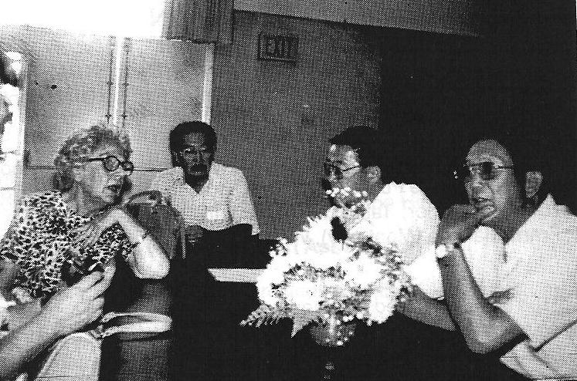
Mrs. Virginia Swanson Yamamoto telling details of the evacuation to me. I was not there at the time. Many may not know how much she did for the people of Terminal Island during the trying period just after Dec. 7, 1941. Through her missionary work, many families’ daily needs were taken care of. She and her co-workers labored unselfishly, distributing canned foods and other items to needy families. She furiously corresponded with government officials in Washington, trying to right the wrong the officials were putting into motion. She would be our unsung heroine during the evacuation.
I include this recent happening at the South Bay Keiro (nursing home) to show how strong our Terminal Island connection is. I met Mrs. Kawashima, our neighbor when we lived on Tuna Street. It was a tearful reunion as she kept asking me about my mother. I wheeled her to Mom’s room, 118-B, and Mrs. Kawashima could not believe how Mom had changed. With total disregard for her own misfortune, she kept saying, “Kino-do-ku.” Once out of the room at Keiro, she would tell other people, “I am from Tami-na-ru.” She was proud she was from Terminal Island. I said to myself, “This is how strong our Terminal Island compassion is.”

