BC Calculus – FDW 3rd Edition – Section 2.3 Even Answers
Quick Review 2.3
2.(a) -2 (b) -1 (c) No limit (d) -1 4. &
6. & 8. 10. any
Section 2.3
2. x = 1, x = 3, both infinite discontinuities 4. None 6. None 8. , infinite type
10. all points not in the domain, x < -1 12.(a) yes (b) yes (c) no (d) no
14. 16. 2 18. yes, assign 0 = f(3)
20.(a) x = 2 (b) removable, let f(2) = 1 22. (a) x = -1 (b) removable, let f(-1) = 0
24.(a) all points not in the domain, also x = 0, 1 (b) x = 0, removable, let f(0) = 0 but
at x = 1, there is a jump discontinuity. 26. 28.
30. 32. For x > 1, y = x – 1 is continuous, hence g(x) is continuous.
34. f(x) is the composite of 2 continuous functions. 36. see #34 38. see #34
40. Since “hole-in-the-graph” trick, f(1) = 2 fills the hole
42. , square root curve shifted 2 to the left
44. , reciprocal functions shifted 1 to the right
46. 48. a = 3 50. a = -1
52.(a) show? Table of values? (b) 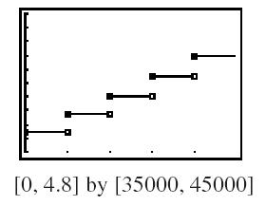continuous for ,
54. False, is considered continous for , but is discontinous at x = 0.
56. B 58. A
60. (a) D: x < -1, x > 0 (b) 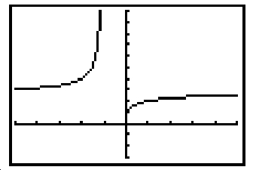(c) can’t divide by zero
(d) at x = 0, removable, as the limit is 1 (e) 2.718 or ‘e’
62. Indirect Proof: Assume that f(x) > 0 and f(x) < 0 on this interval. Then by the Intermediate Value Theorem (for continuous functions), there must be a ‘zero’ where f(x) = 0, but that contradicts our given. Hence, we reject our initial assumption.
64. Oscillating discontinuity as there is always an irrational number between two rationals and vice versa.

