BC Calculus – FDW 3rd Edition – Section 4.4 Even Answers
Quick Review 4.4
2. max (-2,17), min (1,-10) 4. r = 4.01 cm, h = 19.82 cm or r = 7.13 cm, h = 6.26 cm
6. 8. 10. (0,3) or
Section 4.4
2. Max Area = , 4. .
The maximum height of this ‘parabola’ occurs when x = 2, and the rectangle is a square.
6. Max Area = 32, dimensions are 4 by 8. 8. , hence .
10. Dimensions: 12m by 18m with the total length = 72m 12.(a) x = 15ft, y = 5ft (b) The tank material costs $5/sq.ft. and the excavation charge is $10/sq.ft. of the cross-section area of one wall of the hole.
14.(a) 96 ft/sec (b) 256 ft at t = 3sec (c) -128 ft/sec
16. R = height = cm or 6.83 cm. In example 4 the ‘best’ design was taller but less around. This was due to the top of the can.
18.(a) (b) (c) 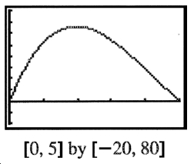
(d) Max Volume when .
20. miles down the shoreline from the nearest point to her boat.
22.
24. P (profit) = R (revenue) – C (cost). To maximize P, dP/dx = 0 or with a min at x = .294 and a max at x = 1.525, hence we need a production level of 1,525 units.
26. When or units, which results in the lowest average cost.
28.(a) at x = 1
(b)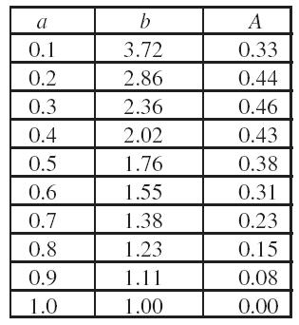(c)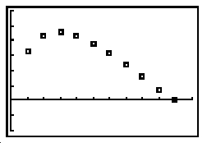(d)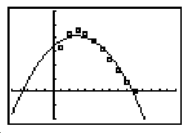 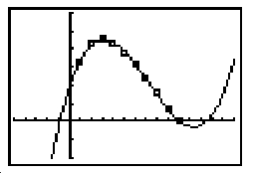 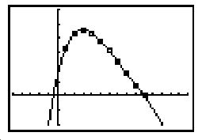
(e)
BC Calculus – Section 4.4 Even Answers (continued)
30. 18 by 18 by 36 (inches)
32.
34. Check out the number line for and you’ll find only one critcal value: . The sign of the derivative changes from – to + which implies a local minimum.
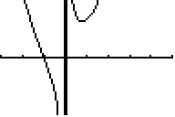
Check out the graph of this rational function: (a = 1)
36. (Hey, if they won’t give me units, I won’t give them any!)
38.(a) (b)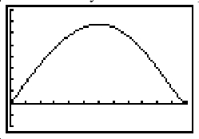(c)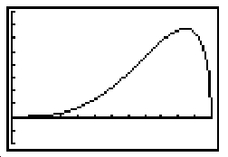
Changing ‘k’ changes the stiffness, but not the dimensions. Changing ‘k’ changes the vertical scale of the graphs.
40.
42. minimum distance = 2
44. (a) since this is the least common multiple (LCM) of the 2 periods, . (b) No, abs. min at
46.(a) (b) max = 1m (c)
48.(a) Kaitlyn tried this with paper! http://ryono.net/apcalc/solutions/4.4.35.doc
(old text: FTDW Section 4.4 #35) (b) (c) 11.04 in
50. 52. False. y = x³ 54. B 56. E 58. when , the rate is
60.(a) (b)
62. 10 items
64.(a) (b) 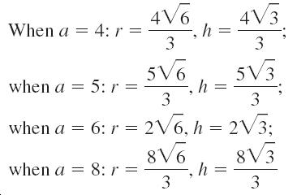(c)

