Carrizo Plains Ecology Notes

A. Soda Lake – Alkali Wetlands
1. We were shown some orthorhomibic crystals of Thenardite. I should have taken a picture as I'm having trouble finding a good one on the internet! We were told by the BLM guide that they formed under the halite(salt) crust of Soda Lake. Evidently you just punch through and reach under to search for them.
2. In 1998 (El Nino?), the lake never dried up. We saw some dead, 4-foot stalks of tall brush that gave the plain its name. (carrizo – tall brush?)
3. We were shown some 'fairy shrimp'. Their eggs are blown with the wind and are drought resistant.
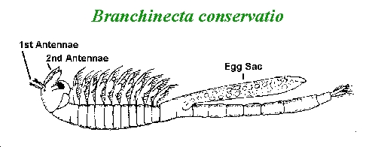
4. Near the shore are two types of salt-resistant shrubs, the salt bush and the iodine bush (even closer to the shore). The salt evaporates on their leaves.
5. A mining operation for a kind of salt lasted about 30 or 40(?) here with a railway out on a finger into the lake.

Links:
1. Minerals of Soda Lake (Halite or table salt or NaCl, Thenardite with orthorhombic crystals)
http://www.mindat.org/loc-3566.html
2. Alkali Wetland of Carrizo - Personal Website
http://www.geocities.com/Yosemite/Gorge/5604/index.html
3. One of the largest akali lakes in California – Birding California
http://www.birdingamerica.com/California/sodalake.htm
4. Vernal Pool Fairy Shrimp
http://sacramento.fws.gov/es/animal_spp_acct/vp_fairy.htm
5. Fairy Shrimp
http://arnica.csustan.edu/esrpp/cfs.htm
6. Mining Soda Lake
http://members.fortunecity.com/mrryono1/CentralCoast/carrizoplain/saltmining.doc

B. Conservation
1. The Tule elk have done well, but the pronghorn antelope have not. One problem is that the cattle fence has its low wire only 16" off the ground. Unlike deer, the pronghorn do not jump fences but rather go under them. They can't get under the fences and are cornered by coyotes. Also, with the low (vs Carrizo (high grass) there is no cover in the open fields. The coyotes have been observed to watch and wait while a pronghorn mother gives birth.
2. The Nature Conservancy and DFG are in charge of managing the over 200,000 acres here. There orientation is for the animals to survive 'naturally' as opposed to the feeding of the pronghorn on Tejon Ranch.
3. The management plan is also using controlled grazing on non-native ground cover before they go-to-seed. Then when the taller, native grasses (bunch grasses, Poa(?)) seed, they should do better. The taller bunch grasses have advantages for the animals but are not as nutritious.

Links:
1. Nature Conservancy – Conservation in Action
http://www.tnccalifornia.org/our_proj/carrizo/conservation.asp
2. California Wilderness Coalition – Carrizo Plain and Caliente Mountains
http://www.calwild.org/resources/pubs/jun98.html
3. California Wilderness Coalition – Potential Wilderness
http://www.calwild.org/places/cc/carrizo.php
4. Endangered Species Recovery Program
http://arnica.csustan.edu/esrpp/esrpp.htm
5. Desert Studies Center – California State University
http://biology.fullerton.edu/facilities/dsc/zz_about.html

C. Animal Life
1. Most of the animals are burrowing. Snakes, Giant kangaroo rat, scorpions, tarantulas, kit foxes, badgers and the burrowing owl. A badger's hole stays wide all the way down. If it starts wide and then goes small, then the badger was after some squirrel or other small animal! The burrowing owl is gray and hard to see as it sits, even on the open ground.
2. Lots of coyote scat around.
3. No condors. Someone saw a bobcat the night before at Selby Campground. The water tastes terrible, use it to wash your hands!
4. Birds nest all over Painted Rock. The rock has been closed from March 1st through May (except for docent-led groups on Saturdays) to protect nesting falcons. When we were led into the rock area in April, we were told to be especially quiet. A kestrel nest was observed on top of an old tank as we drove south out of the Carrizo Plain. Our docent said she thought some ravens had actually taken over the falcon nests in the rock. Meadowlarks like to sit on fence posts.
5. They don't want those bees in the back of the rock, but if they're removed it's possible that killer bees will take their place, so...
6. The elk are up higher in the Caliente Mountains.
7. In the Painted Rock, below the nests, look for the small, skeletal remains of prey. Note how the guano builds up and on the southwest side of the rock, a large opening is almost entirely closed up!

Links:
1. Birding the Carrizo Plain – birdingamerica.com
http://www.birdingamerica.com/California/carrizoplain.htm
2. Central Coast Birding Trail – La Purisima Audubon Society
http://lpas.westhost.com/CCBT/SLO.htm
3. Short-nosed Kangaroo Rat – California Department of Fish and Game
http://www.dfg.ca.gov/hcpb/species/jsp/more_info.jsp?specy=mammals&idNum=46

D. Plant Life
1. The horehound that grows on the south (warmer) side of Painted Rock is a favorite spot for rattlesnakes. Don't go up to the rock on that warm, sunny side! Sometimes volunteer help will come in to remove the horehound.
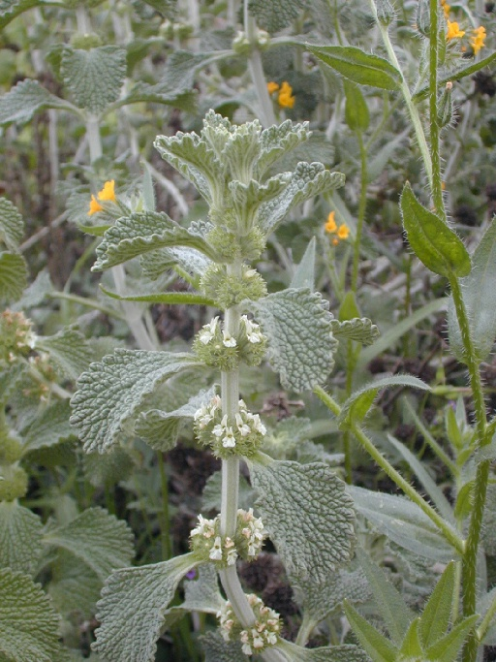
2. Call ahead to find out exactly when the wildflowers are in bloom. We still saw them along Hwy 58 heading toward Carrizo Plain from San Luis Osbispo.
3. The (purple) larkspur is common. There was even one bush of the gypsum (white) larkspur which is uncommon. Both are poisonous to cattle. 30 were lost when the plain was opened up to the cattle.

Links:
1. Plant List – BLM
http://www.ca.blm.gov/bakersfield/plantlistkey.html

