Pedro Fages – Painted Rock, Carrizo Plain (?)

As you walk around to the back of the rock, look back at a larger boulder. Carved there you may be able to make out something about ESPANA and NAVARRE and their is a square with a design in it. In 1772 Pedro Fages is said to have discovered the San Joaquin Valley. He is said to have traveled from what is now Fort Tejon to San Luis Obispo and may have come through the Carrizo Plain. Could the Chumash have shown him their Painted Rock and could he have been allowed to carve the into the rock. Is this a claim of land for Spain???

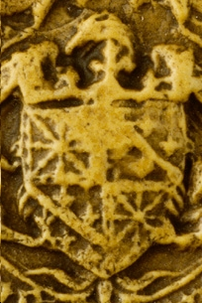 Navarre seal (1409) 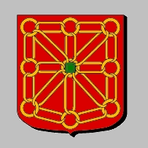 French Heraldry

Who was Pedro Fages and what was he doing here in the 1770's?

Links:
1. The Catalonian Volunteers And Their Assignments In Northwestern New Spain, 1767-1803
http://usaic.hua.army.mil/History/Html/sanchez.html
(or when the link goes bad!) Pedro Fages: catalonianvolunteers.doc
2. Navarre Heraldry
http://www.heraldica.org/topics/france/navarre.htm
(when the link goes...) Navarre History: navarre.doc

