Chumash Indian Rock Art – SLO 79

Famous photo of the main panel – 1890's
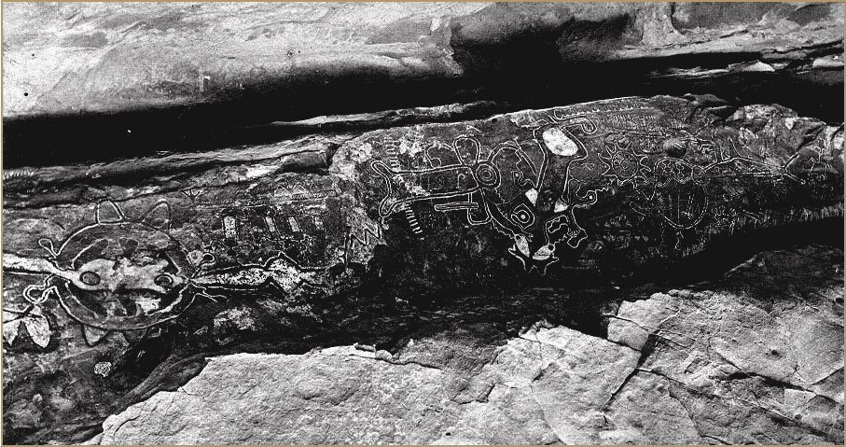

SLO 79 - Drawing 3: No profiles. Hands up in prayer or respect? Vertical Chain (black then white) may be the iodine bush(?). Sun wheel.

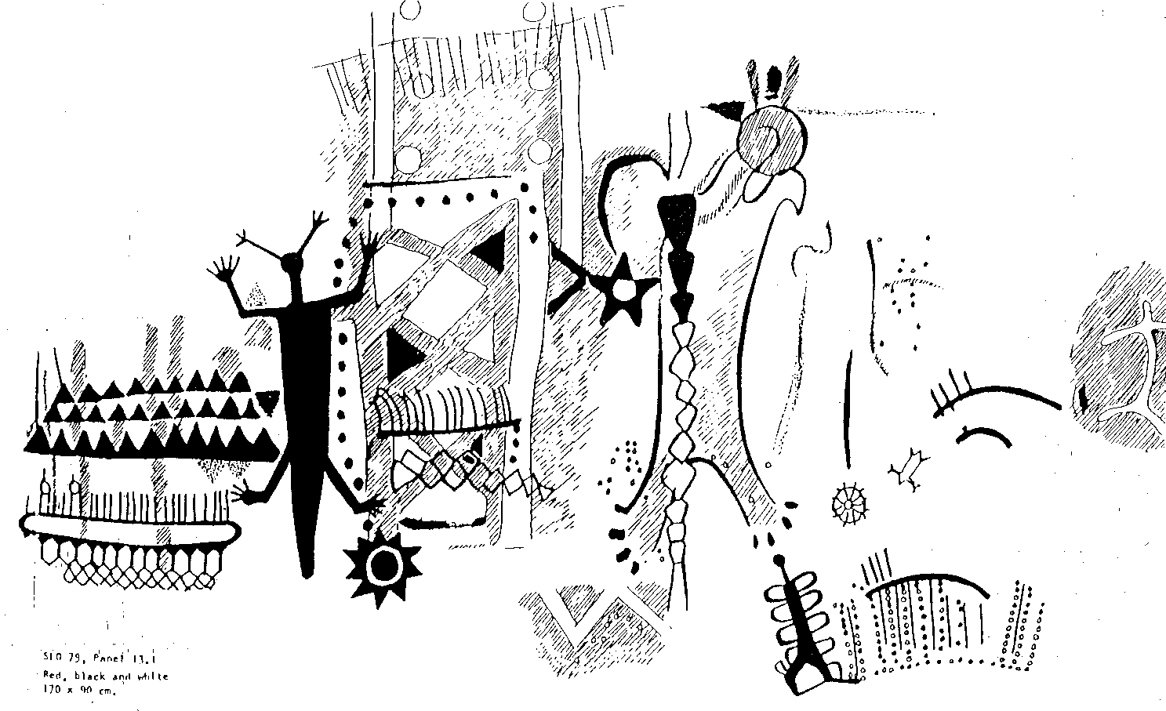

Chumash Indian Rock Art – SLO 79 p. 2

Drawing 4 – Sun Wheel is classic Chumash

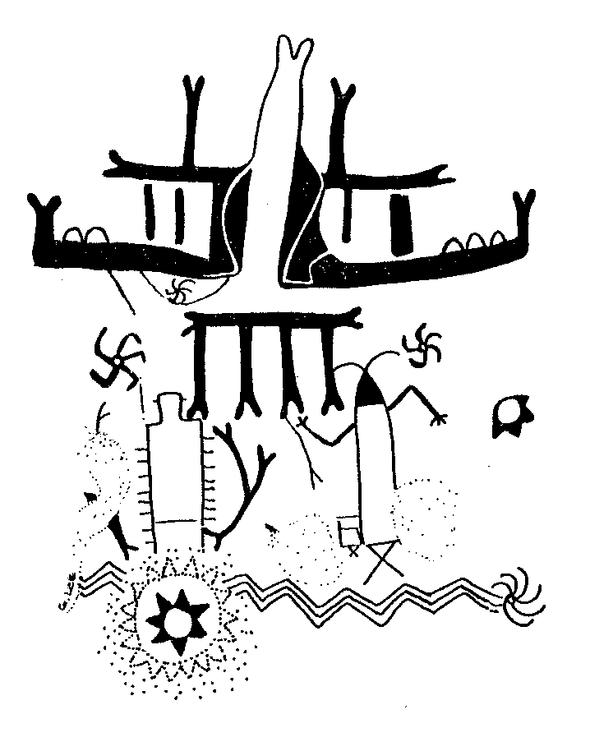
Drawing 5 – Coyote

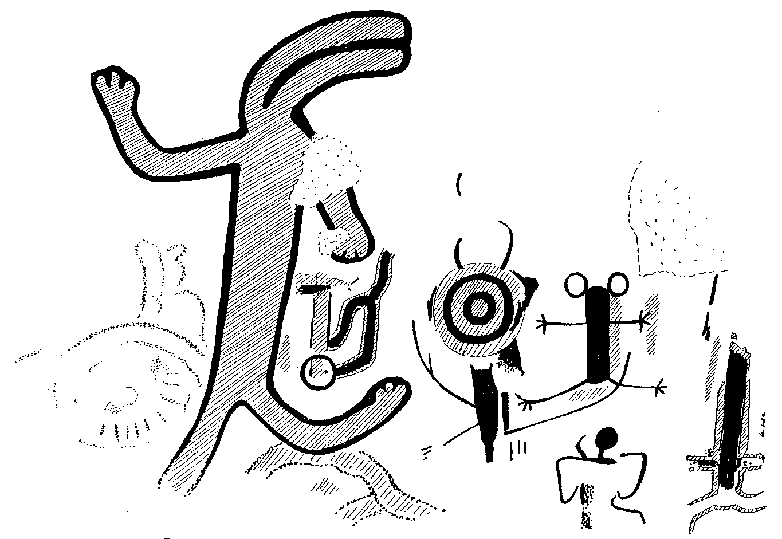

Chumash Indian Rock Art – SLO 79 p. 3

Drawing 6 – Red Spiral (here black) in the throat (cavity) – Common Chumash feature

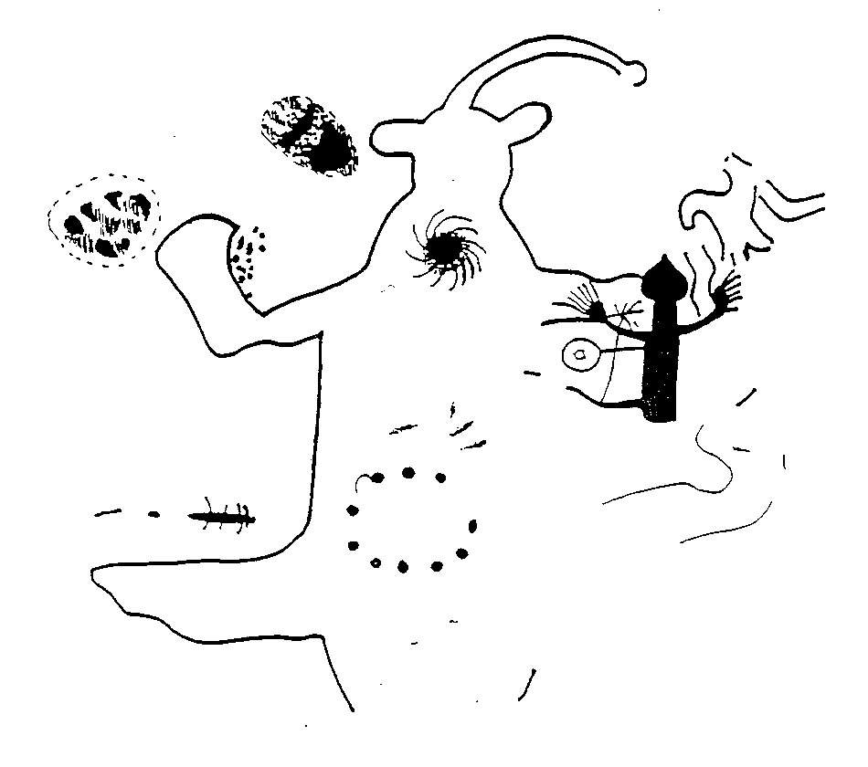

Links:
1. Painted Cave, Santa Barbara – Photos by Hammond
http://www.thing.net/~grist/l&d/ancestors/chuma01.htm
2. Chumash Art on the Internet – Commentary by John Anderson
http://www.expage.com/page/chumrock66
http://www.expage.com/page/chumrock979
3. Rock Art Archives – UCLA Special Collections (Grant, Crosby, others)
http://www.sscnet.ucla.edu/ioa/rockart/campbell.html
4. Shamanic Traditions – William Hyder and Georgia Lee
http://zzyx.ucsc.edu/Comp/Bill/shamtrad.html
5. Cambell Grant – 1965 Interview
http://archivesofamericanart.si.edu/oralhist/grant65.htm
6. Southern California History – Selective Biography
http://cogweb.ucla.edu/Chumash/Bibliography.html
7. Chumash Painted Cave State Historic Park
http://cal-parks.ca.gov/default.asp?page_id=602
8. The Kagismuwas
http://john888.freeyellow.com/kagis.html
9. The Treasure of Carrizo Plain – Santa Barbara Independent (online)
http://www.independent.com/community/feature_0744.htm
10. Sierra Madre Ridge – Painted Rock
http://gorp.com/gorp/resource/us_national_forest/ca/see_losp.htm
11. Mesa Springs – Cerro Noroeste (Mount Abel) – Chumash sites
http://kernkaweah.sierraclub.org/condor/Condor11.html

