Absolute Value – Problems
1. Graph {(x,y) | y = ½ (x + |x|) , −3 ≤ x ≤ 3}
2. Graph y = ½ (x − |x|) , −3 ≤ x ≤ 3
3. Graph y = ½ (|x| − x) , |x| ≤ 3
4. Graph y = 2|x −1| − |x| + 2|x + 1| − 5 , |x| ≤ 3
5. Solve: |2x − 1| < 5
6. Solve: |10x| < 100
7. Solve: 2|x − 3| − 2 < 8
8. Solve: |x − 2| < −4
9. Solve: |3x + 1| ≥ 2
10. Solve:
11. Solve: |x − 2| + x > 2
12. Graph y > |x − 5|
13. Graph
14. Graph
15. Graph {(x,y) | |x| < 2}
16. Graph { x | |x| < 2}
17. Graph y = |x − 3| + 2
18. Graph y = −|2x − 4| − 3
19. Graph |x| + |y| ≤ 1
20. Graph |x| − |y| = 3
21. Graph y =
22. Graph | f(x) | if f(x) = −x² + 1
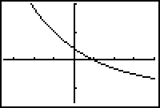
23. Graph | f(x) | if f(x) = Cos⁻¹x
24. Graph f(|x|) if f(x) = Sin⁻¹x
25. Graph | f(|x|) | if f(x) has the graph shown here:
26. Graph (a) y = log₂(x − 3)
(b) y = 2log₂(x − 3)
(c) y = |log₂(x − 3)|
(d) y = log₂|x − 3|
27. Graph (a) y = x² − 4x + 3
(b) y = |x² − 4x + 3|
(c) y = x² − 4|x| + 3
(d) y = |x² − 4|x| + 3|
28. Graph y = 2^{−|x|}
29. Graph y =
30. Graph (a) y = sec|x| (b) y = |sec x| (c) y = |sin x|
31. Graph (a) y = |Cot⁻¹x| (b) y = cot |x| (c) y = |csc x|
Absolute Value – Solutions
1. y = ½ (x + |x|) 2. y = ½ (x − |x|) 3. y = ½ (|x| − x) 4. y = 2|x −1| − |x| + 2|x + 1| − 5
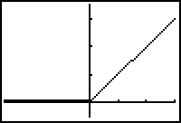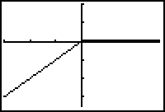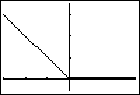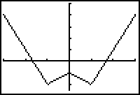

5. −2 < x < 3 6. −10 < x < 10 or |x| < 10 7. −2 < x < 8 8. Ø
9. x ≥ 1/3 or x ≤ −1 10. x > 3 or x < 1 11. x > 2

12. y > |x − 5| 13. 14. 15. {(x,y) | |x| < 2}

16. { x | |x| < 2} 17. y = |x − 3| + 2 18. y = −|2x − 4| − 3 19. |x| + |y| ≤ 1
o o
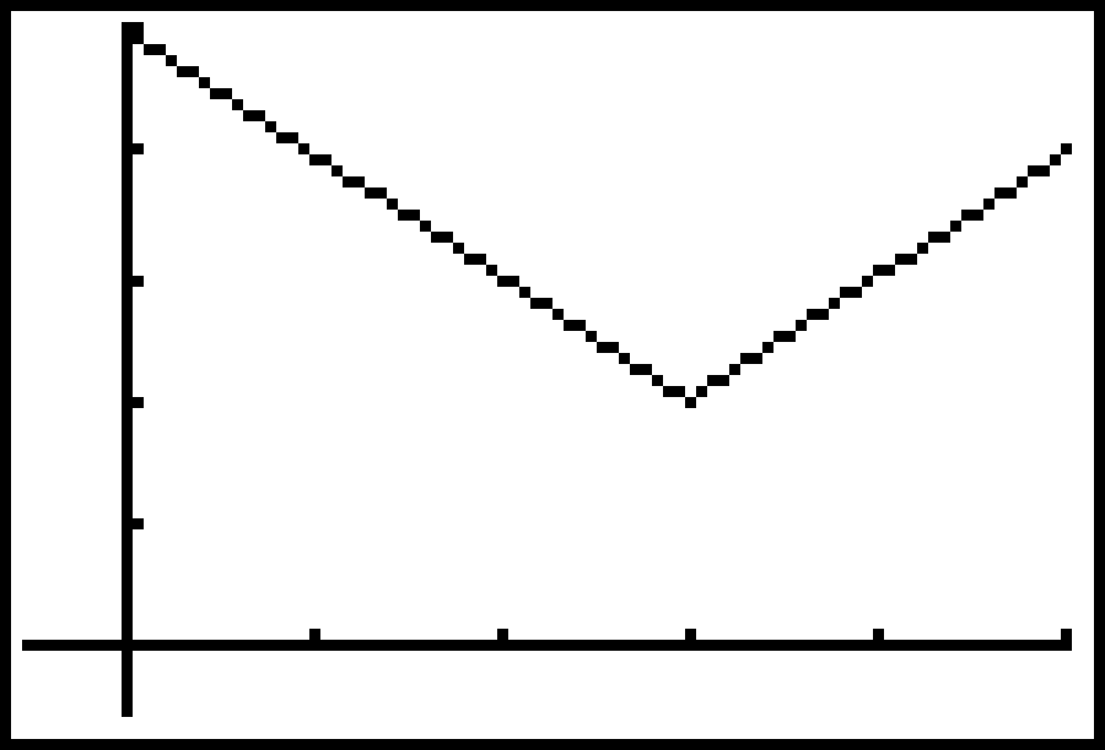
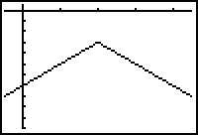
−2 2

20. |x| − |y| = 3 21. y = 22. y = |−x² + 1| 23. y = | Cos⁻¹x |
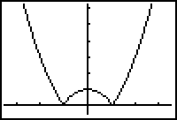
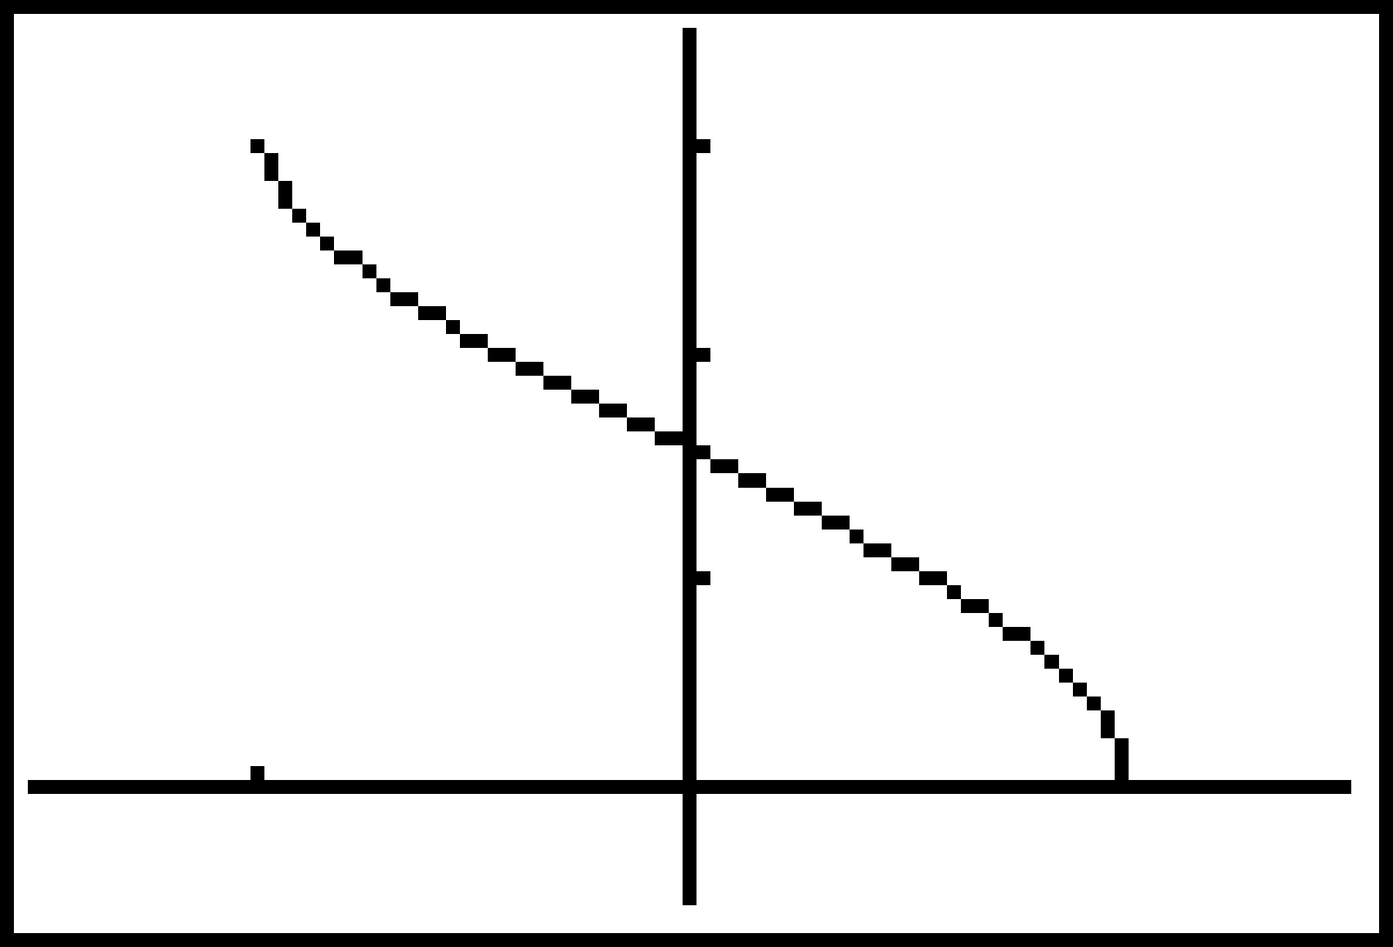
Absolute Value – Solutions
24. y = | Sin⁻¹x | 25.
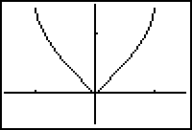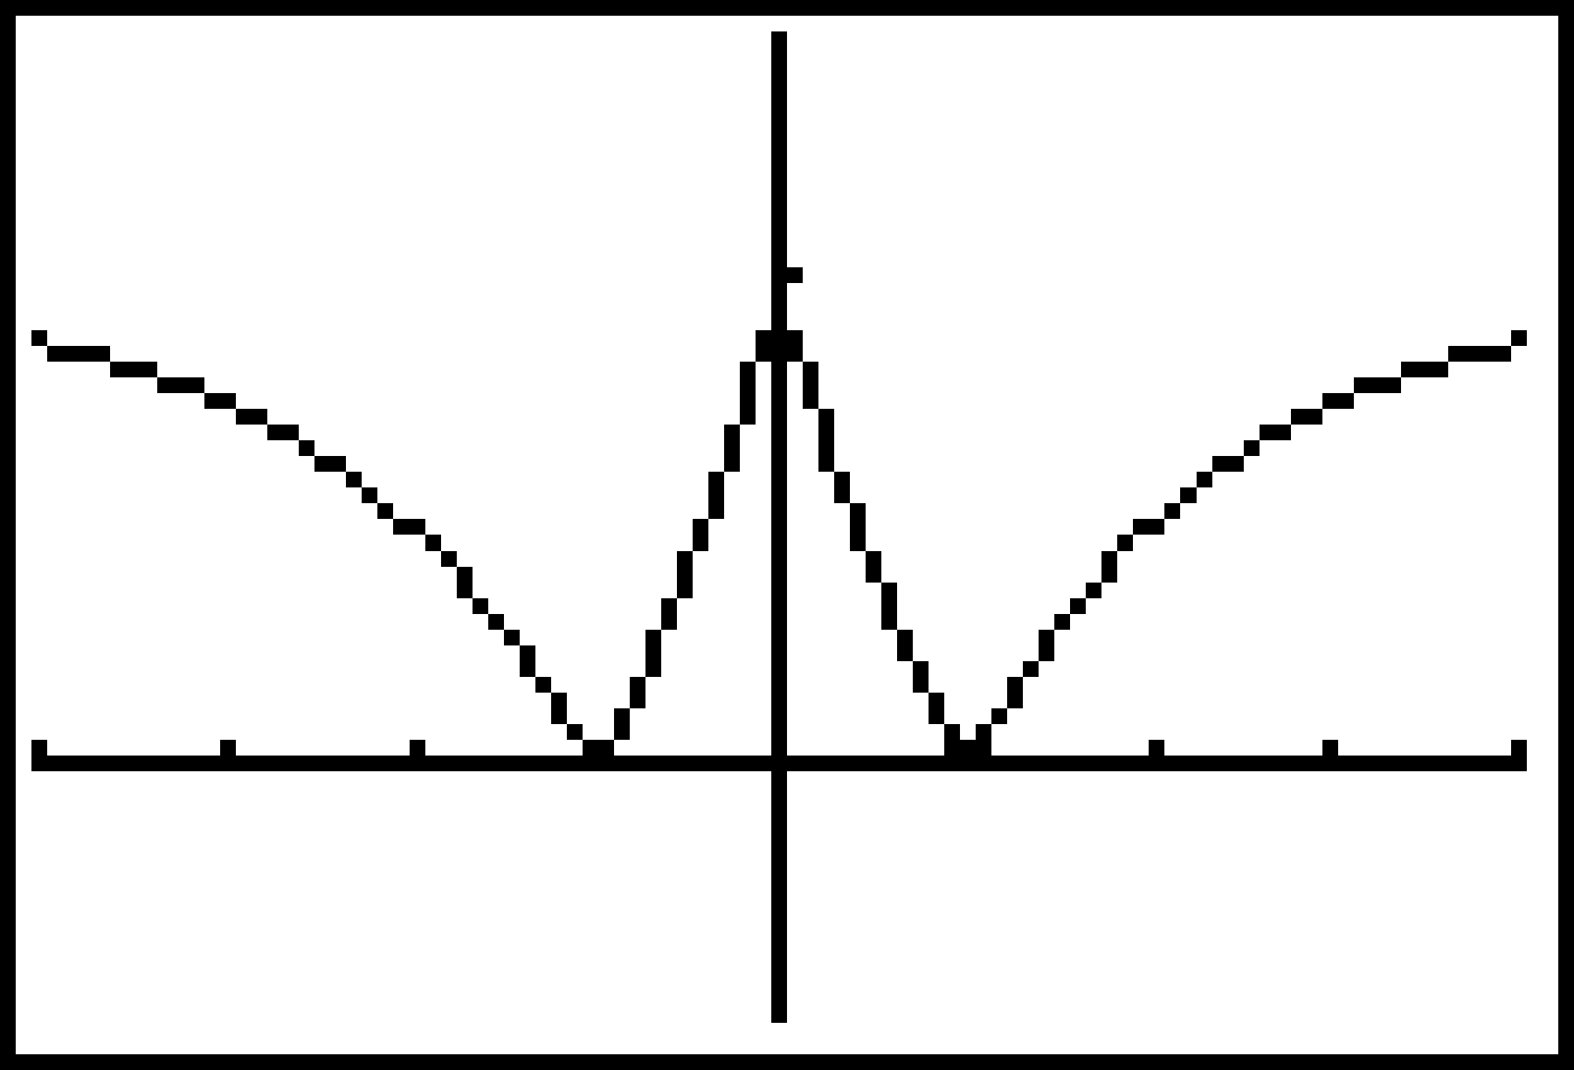
26. (a) y = log₂(x − 3) (b) y = 2log₂(x − 3) (c) y = |log₂(x − 3)| (d) y = log₂|x − 3| 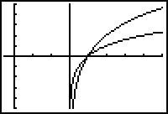 (c) 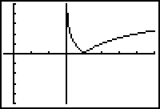 (d) 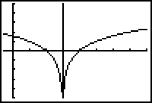
(b)

(a)

27. (a) y = x² − 4x + 3 (b) y = |x² − 4x + 3| (c) y = x² − 4|x| + 3 (d) y = |x² − 4|x| + 3|
(a)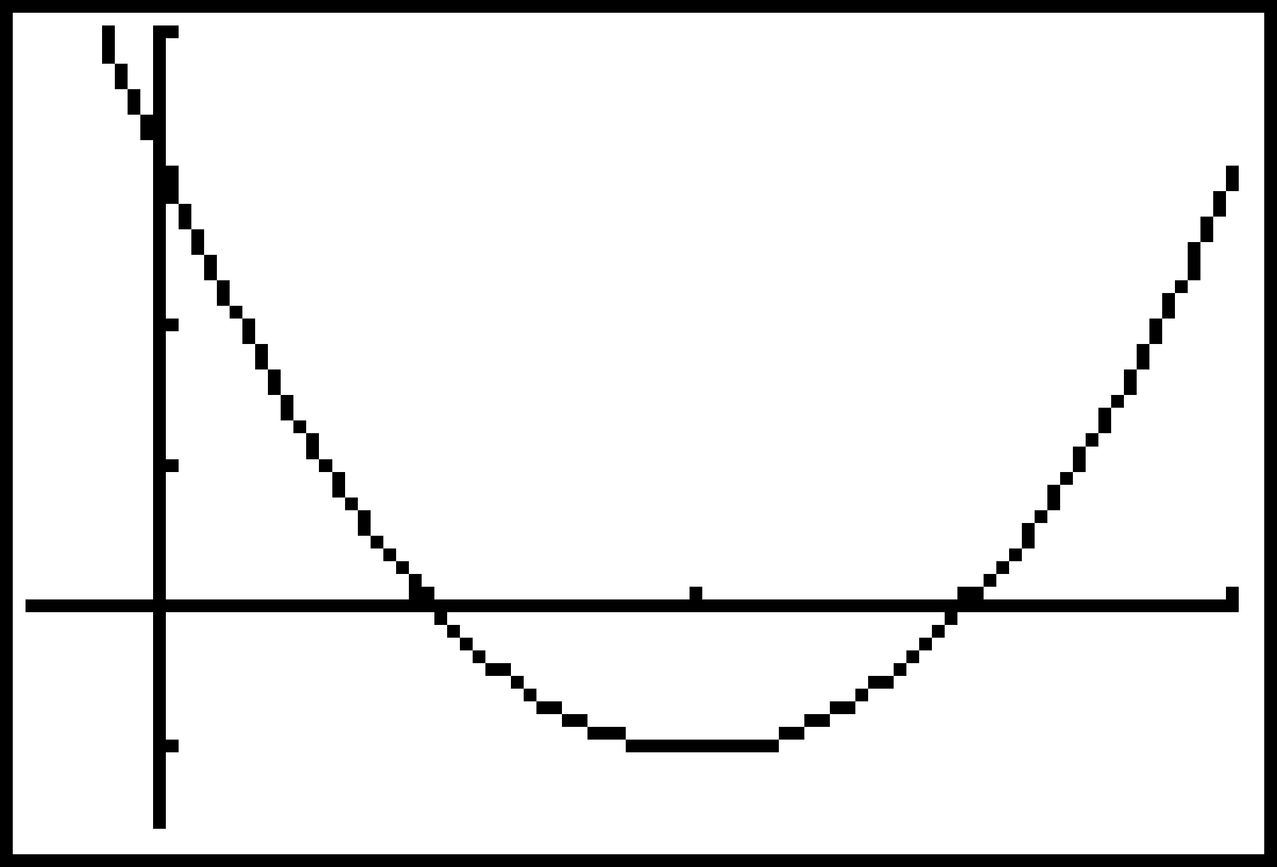 (b)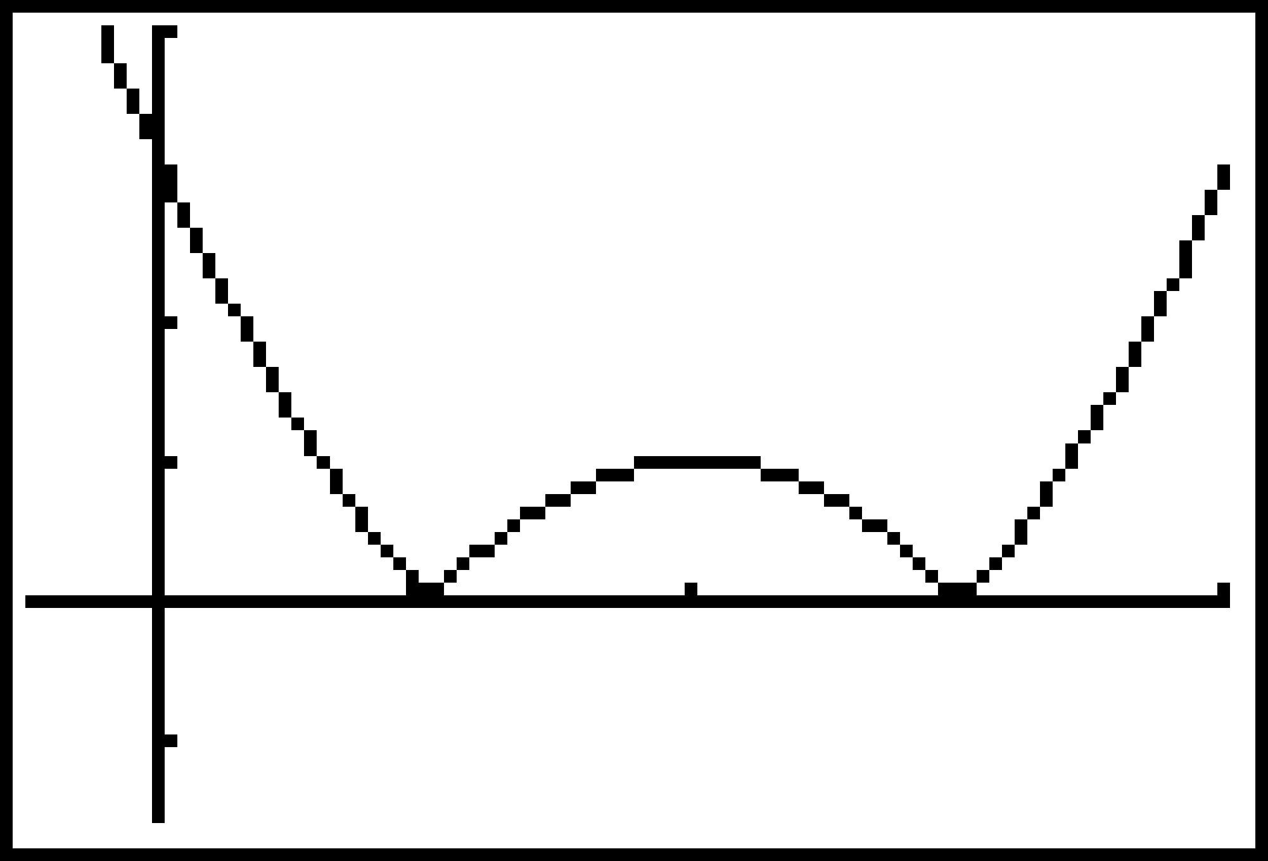 (c)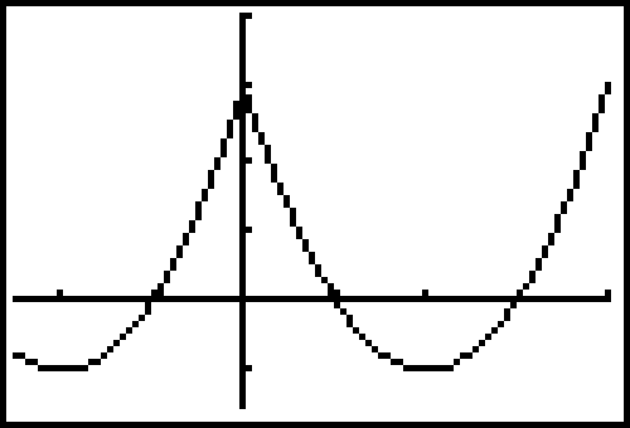 (d) 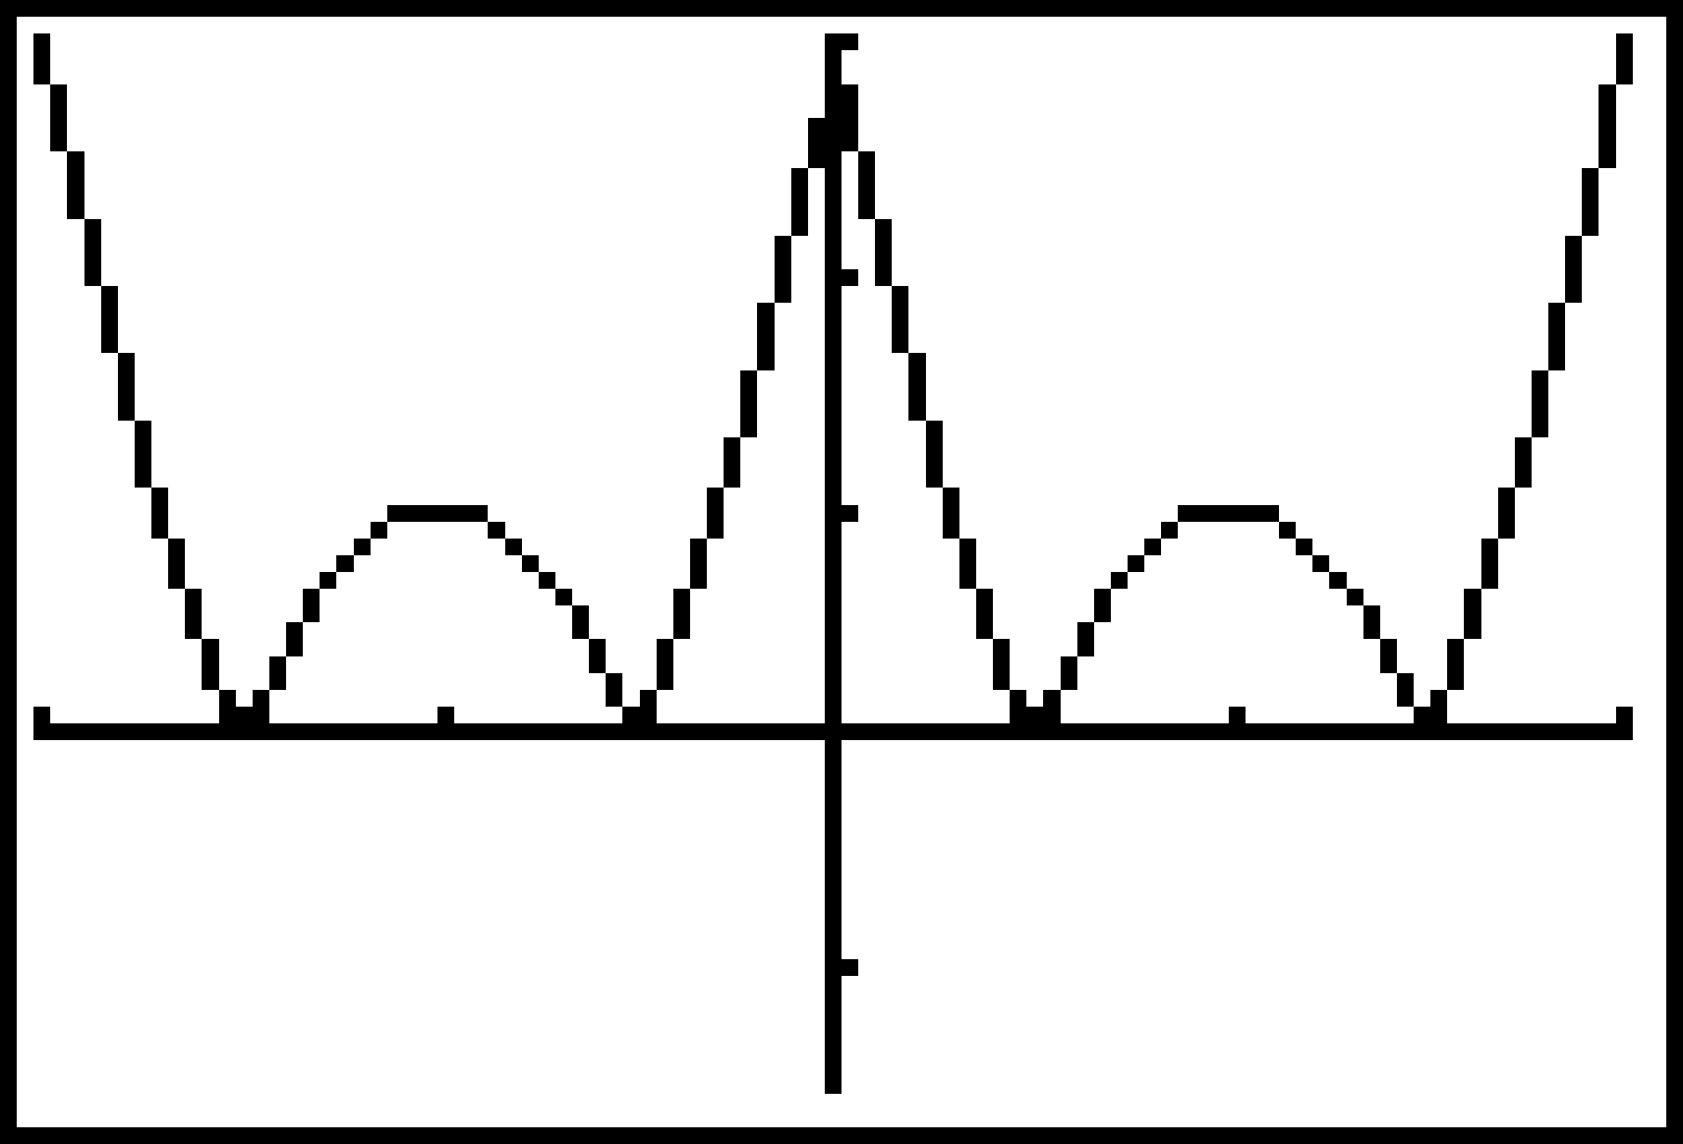
28. y = 2^{−|x|} 29. Graph y =
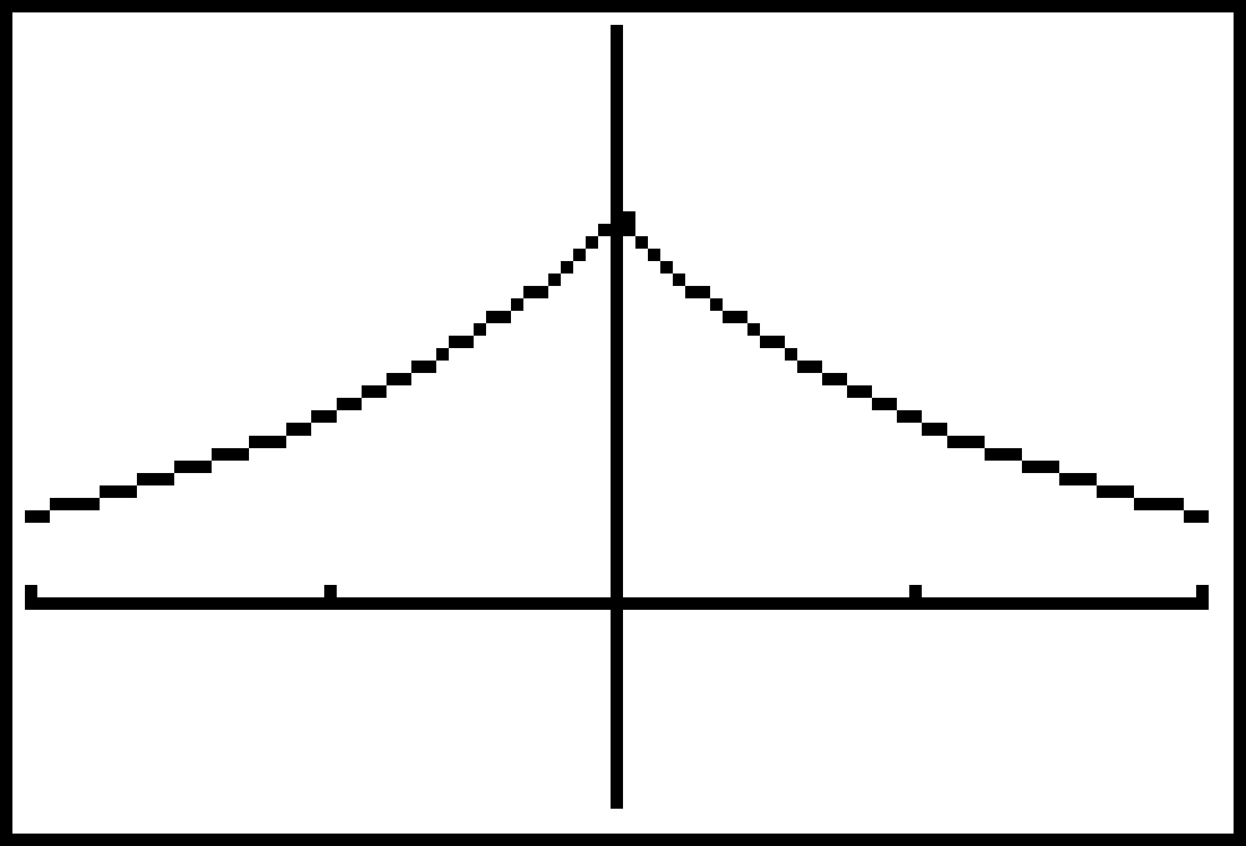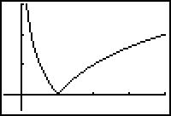
30. (a) y = sec|x| = sec x (b) y = |sec x| (c) y = |sin x|
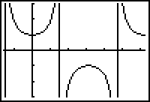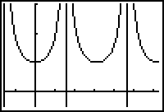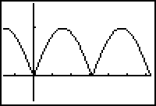
31. (a) y = |Cot⁻¹x| = Cot⁻¹x (b) y = cot |x| (c) y = |csc x|
