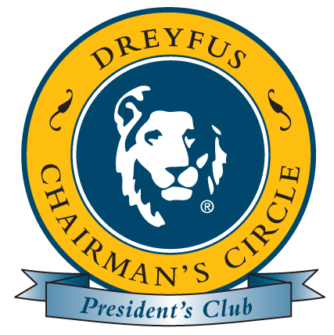 ~ LONDON PROGRAM DETAILS ~

Please print this document for your reference

Dates
Chairman’s Circle: April 30 – May 4, 2008 (Wednesday – Sunday)
President’s Club: May 1 – 4, 2008 (Thursday – Sunday)

Travel Arrangements
- You should have received via email an e-Ticket travel invoice for you and your guest from American Express Business Travel. Please be sure you receive and review this information BEFORE you travel.

- For information regarding Virgin Atlantic’s Premium Economy and its perks, visit the following link – www.virgin-atlantic.com/en/gb/travellingwithus/premiumeconomy/premiumcomfort.jsp

- REMEMBER YOUR PASSPORT!

Airport Transfers
- Based on your flights in accordance with the program dates, transportation for you and your guest to/from London’s Heathrow Airport will be arranged by Dreyfus Corporate Events (roundtrip cost & gratuities paid by Dreyfus). See Confirmation Sheet for details and instructions.

Hotel Accommodations
Claridge’s Check-In: after 2:00 PM*
Brook Street, Mayfair Check-Out: 12:00 PM
London WIK 4HR
www.claridges.co.uk.com

Claridge’s is located in the heart of Mayfair, moments from Bond Street, Oxford Street and Hyde Park.

- Reservations will be pre-arranged on a group rooming list by Dreyfus Corporate Events. We will provide the hotel with each guest’s passport number. Please note, you may also be required to provide your actual passport upon check-in.

- One guest room per member (room rate & tax only) will be provided by Dreyfus during the applicable program dates. Accommodations include a Deluxe King bed. If you require two beds, please note the configuration is typically two twin beds (based on limited inventory, this is subject to availability).

- Roundtrip porterage fees (per person) will be provided by Dreyfus.

- Incidental charges will be at your own expense.

- *The hotel will make every effort to accommodate early check-in, however, it is not guaranteed.

Meals
Breakfast – Dreyfus will pay for a traditional English breakfast (28 GBP per person) for you and your guest each morning (as applicable) served in the hotel’s restaurant or in-room dining. The charges should be billed directly to your guest room. The Foyer serves breakfast from 7AM – 10AM on Monday thru Saturday and on Sunday from 8AM – 10:30AM. Breakfast via Room Service is available from 6AM – 11AM.
~ Continued ~


~ LONDON PROGRAM DETAILS ~

Itinerary

Wednesday, April 30th Arrival of Chairman’s Circle members and their guests
Dinner - A special reception and dinner will be held at Mosimann’s Private Dining Club exclusively for Chairman’s Circle members and their guests. The evening will be hosted by Dreyfus senior management. The group will meet in the Hotel Lobby at 6:30 PM. Group transportation will be provided.

Attire (suggested) – Business attire is appropriate for this evening; gentlemen should wear a suit & tie and ladies a dress, skirt or pants suit.

Thursday, May 1st Arrival of President’s Club members and their guests
Chairman’s Circle members and their guests may enjoy the day at leisure.

Dinner – A welcome reception and buffet dinner will be held for Chairman’s Circle & President’s Club members and their guests at 6:30 PM in the Drawing Room & French Salon located on the Lobby Level.

Attire (suggested) – Smart casual attire is appropriate for this evening; gentlemen should wear slacks, dress shirt and a sport jacket (tie is not necessary) and ladies a pants suit, slacks or skirt.

Friday, May 2nd
Meeting - A mandatory business meeting for Chairman’s Circle & President’s Club members will be held at the hotel from 8:30 – 10:30 AM in the Kensington Room on the Sixth Floor. A traditional English Buffet breakfast will be available at 7:30 AM.

Attire (suggested) – Business casual attire is appropriate for the meeting; gentlemen may wear khakis, slacks and a collared shirt and ladies may wear slacks. Meeting room temperatures will vary so be sure to bring a sweater or jacket.

Your guest may enjoy breakfast at their leisure, compliments of Dreyfus. The charges (28 GBP pp) should be billed to your guest room. Enjoy the afternoon and evening at your leisure.

Saturday, May 3rd
Spend the day exploring London! Enjoy breakfast at your leisure, compliments of Dreyfus. The charges (28 GBP pp) should be billed to your guest room.

Awards Dinner – Kensington Palace (Princess Diana’s former residence). The group will meet in the Hotel Lobby at 6:00 PM for group transportation. During the reception, private group tours will be conducted. Group photos (Chairman’s Circle & President’s Club) will be taken prior to dinner.

Attire (suggested) – Business attire is appropriate for this evening; gentlemen should wear a suit & tie and ladies a cocktail dress or skirt. Please note: due to the uneven floors of the palace, ladies should be careful of wearing high heels, especially during the tour.

Sunday, May 4th
Departure Day – have breakfast at your leisure, compliments of Dreyfus. The charges (28 GBP pp) should be billed to your guest room prior to check out. Incidental charges should be reconciled prior to departure.

If you have any questions please contact Gina DiChiara at 212-922-6697 or Lori Keenan at 212-922-6674.

See you in London!

